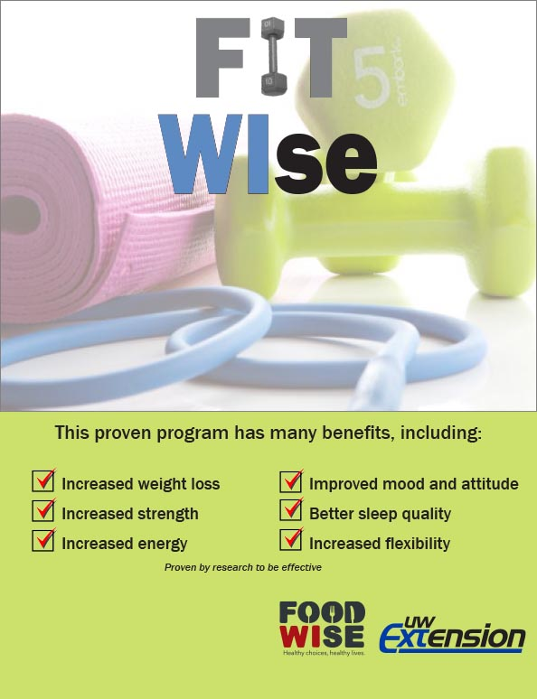

FitWIse is a strength training program

for adult women and men.

Classes are held two times a week, and include

weight training, flexibility, balance exercises,

and nutrition information.

This program is based on the StrongWomen Program- a national evidence-based community exercise and nutrition program created by Dr. Miriam E. Nelson and colleagues @ Tufts University, supported by Cornell University and brought to you by the University of WI-Extension.



**To learn more about FitWIse contact**

**Julie Montgomery, FoodWIse Coordinator**

**715-395-1427 or email julie.montgomery@ces.uwex.edu**

email sheila.deforest@ces.uwex.edu

An EEO/AA employer, University of Wisconsin-Extension provides equal opportunities in employment and programming, including Title IX and ADA requirements. FoodWIse is funded by the USDA Supplemental Nutrition Assistance Program - SNAP. SNAP/FoodShare helps families buy the food they need for good health. Visit access.wi.gov to learn how to apply or call 715-395-1304.