DOUGLAS COUNTY ASSOCIATION FOR
HOME AND COMMUNITY EDUCATION (HCE)
HCE QUILT-A-THON
(making comforters for kids in crisis)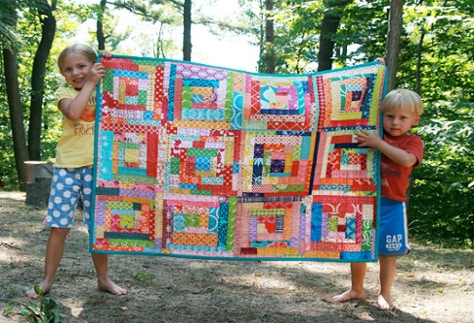
10:00 a.m. – 3:00 p.m.
Thursday, March 23, 2017
Mariner Retail and Business Center, Superior
Volunteers welcome! Donations needed!
(Come and help for whatever time you can spare.)
Items to Bring (if you have on hand) or………
Just Yourself and also a Friend!!
Needles for tying, Scissors,
Juvenile fabrics (especially flannel),
Yardstick or measuring tape,
sewing machine (with bobbins and thread),
Small, unfinished (or finished) quilts
36” x 36” to about 38” x 44”
PLEASE COME AND JOIN US!

