Cloverbud Record for:
Name: | Record Year:
Address: | Parents:
Club: | Leaders Name:
Years in 4-H including
this year:
My projects this year are:

I like being a Cloverbud because:

This year I learned about: |  | Next year I want to learn about:
In my club I got to:

I participated in these activities:

Draw or attach a picture of your favorite project:

Here are some projects I made (attach or draw pictures):

Comments from your leader:
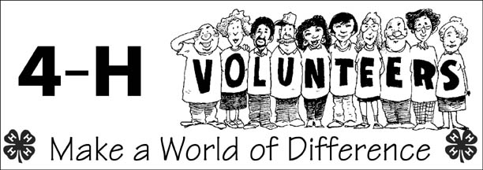

Suggestions for next year:

