4HOnline – Club manager

Updated: August 6, 2013

OVERVIEW AND INITIAL ACCESS
4HOnline offers two levels of access to adults. First, all adult family members have access to their family’s enrollment data. Secondly, for those adults with designated leader roles, it is possible to grant “Club Manager” or “Project Leader” access, which provides greater access to member enrollment data.

To access 4HOnline as a Club Manager, you must:
- Be enrolled as a screened adult volunteer in 4HOnline.
- Know the family email address used to enroll in 4HOnline.
- Know (or request from 4HOnline) your family login password.
- Be granted Club Manger access by Extension staff.
- Be provided with the club password by Extension staff.

LOGGING IN

Start by going to https://wi.4honline.com

Once granted Club Manager access, you will see the [Club Manager] toolbar after you login to 4HOnline:

- Clicking on [Continue to Family] will bring you to your regular data access screens.
- Under [Club Leader Login], choose your name under [Select a profile], then your club.
- The club [Password] will be provided by your Extension staff.
After clicking on [Login to Club], you will see the Club Manager dashboard, and by default, you will be looking at the [Confirm Members] screen.
Note that “Members” refers to family members, who may be Youth or Adult “Members”.

Confirm Members
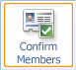
[Confirm Members] lists all pending youth and adult members for your club. In other words, these are people who have applied online, but have not yet been approved by Extension staff. As a Club Manager, you may be interested in following up with these families in some way.
In addition to allowing you to review their submitted enrollment data, this screen allows you to “Confirm” their enrollment, but their enrollment must still be ultimately accepted (confirmed) by Extension staff.

Members
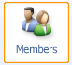
[Members] gives you access to a listing of your club members, where you can access each individual member (both youth and adult members). Clicking on the [Edit] button next to each listed member will then display the details of their enrollment (you won’t actually be able to edit their enrollment data).
- To return from viewing a member’s details, either click the [Close] button at the bottom of the screen, or click on one of the dashboard icons (Members, Search, etc.).
- Clicking on [Return to the Family Account] will log you out of your Club Manager access.

Search
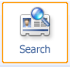
[Search] allows you to search for or apply various filters to a listings of your club members. This can be helpful when looking for a specific member (or group of members) and it also the quickest way to use the [Quick Exports] option (info below) to print a list of the listed members.
- In the [Keyword…] field, you can search by any field (phone number, e-mail, name, etc.) but it is a “literal” search. If you enter “john”, you’ll get John Smith and Sally Johnson and Dwight Marks who lives at 2345 Johns Road SE, but NOT Jon Allen.
- You can also use any of the checkbox “groups” to filter the displayed results.
- If you do not select any of the checkboxes in a group (as indicated by the red boxes in the screenshot) 4HOnline will not apply any filter, and the listing of members (youth and adult) will include members with any of that particular criteria.
- Searches are remembered from your previous session, so if you are not seeing the expected listing, check the search/filter settings. To list all members, leave the [Keyword] field blank and do not check ANY checkboxes, then click [Search]
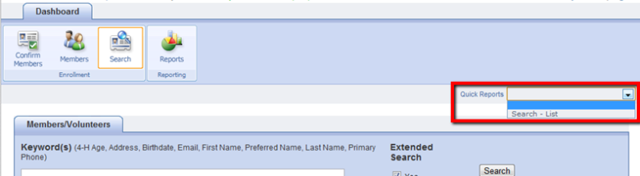
- Click on [Quick Exports] menu to print a simple contact list for the club members currently being displayed.

Reports
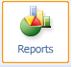
[Reports] is where you can create and print reports for your club members.
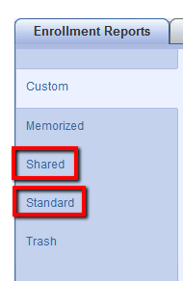
There are five report “directories” (tabs on the left side of the screen): (Standard, Memorized, Custom, Shared, and Trash) but you will only find reports under [Standard] and [Shared].
- [Standard] reports are system generated reports. Several of these reports will be helpful, including the[Club - Directory (Primary Club)] report.
- Under [Shared] reports are several reports designed just for club leaders. If additional reports are needed (or modifications are needed on the reports), please tell your county 4-H office.

To run/access a report:
- Right click on the desired report
  - [Run] will simply display the report and provide an option to print it
  - [Family Labels] will generate one label per family for the individuals listed in the report.
  - [Member Labels] will generate one label per member (youth or adult) for the individuals listed in the report.
  - [Export to Excel] generates an Excel sheet that can be manipulated as needed
  - [Export to PDF] generates a PDF that can be saved and/or emailed

Depending on your browser choice and computer configuration, you may need to allow popups or change your browsers security settings to view the reports.

Emailing club members from within 4HOnline is not yet possible, but is being developed. In the meantime, the quickest option is to click on Email List on the Search screen of your dashboard. This will give you a list of emails for all members and leaders listed below. Copy and paste these addresses into your email client.

University of Wisconsin, U.S. Department of Agriculture and Wisconsin counties cooperating. UW-Extension provides equal opportunities in employment and programming including Title IX and ADA.

