4HOnline

4HOnline Project Leader user guide
Created: August 12, 2013

Overview and initial access
4HOnline offers two levels of access to adults. First, all adult family members have access to their family’s enrollment data. Secondly, for those adults with designated leader roles, it is possible to grant “Club Manager” or “Project Leader” access, which provides greater access to member enrollment data.

To access 4HOnline as a Project Leader, you must:
- Be enrolled as a screened adult volunteer in 4HOnline.
- Know the family email address used to enroll in 4HOnline.
- Know (or request from 4HOnline) your family login password.
- Be granted Project Leader access by Extension staff.
- Be provided with the project password by Extension staff.
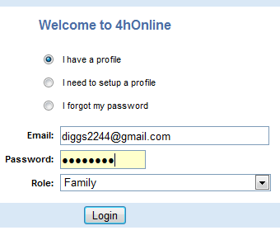
To log on to 4HOnline:
- Go to http://wi.4honline.com
(notice that there is no “www” in that address).
- Enter your email address and password.

Once granted Club Manager access, you will see the [Project Leader Login] toolbar whenever you log in to 4HOnline:

- Clicking on [Continue to Family] will bring you to your regular data access screens.
- To log in as a Project Leader, choose your name under [Select a profile], then select a project from the second dropdown.
- Enter the project [Password], which will be provided by your Extension staff.

After clicking on [Login to Project], you will see a list of members enrolled in this project.
- To print reports or mailing labels, click on the [Quick Reports]
- For a list of email addresses you can copy into your email client, click on Email List.

Additional reporting capabilities are being developed and will appear on this screen over time.

University of Wisconsin, U.S. Department of Agriculture and Wisconsin counties cooperating. UW-Extension provides equal opportunities in employment and programming including Title IX and ADA.

