4-H Youth Development Team
December 2015 Highlights
4-H Outreach:
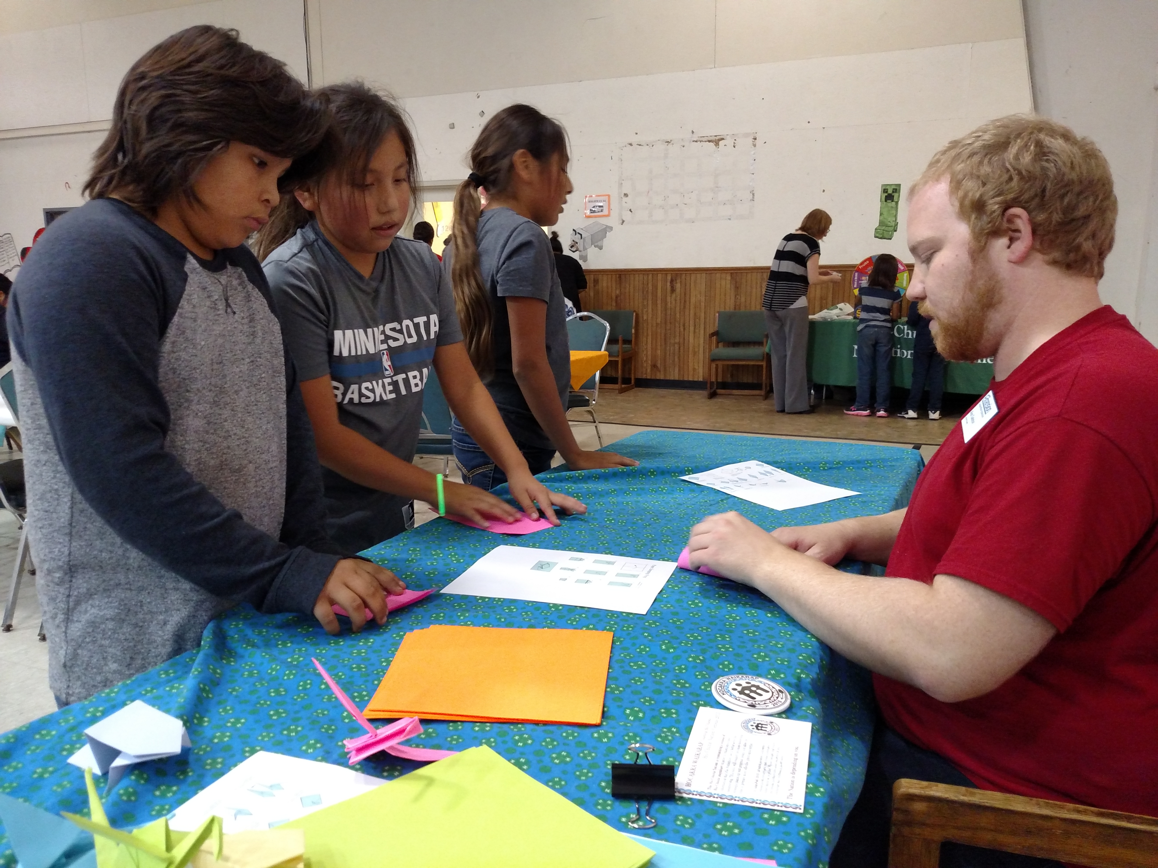
This month’s Family Night theme was Thanksgiving. We taught the youth how to make paper frogs (for practice) and paper cranes, a symbol for peace in Japan.

Alex has also created monthly STEM kits for Boys & Girls Club and Ho-Chunk Nation Youth Services 4th-5th grade youth in November and December.
Volunteer Development:
- Annual Volunteer & Leaders Retreat – 12 adult and 1 youth volunteer attended the Retreat in Hixton. They learned how to create a welcoming club environment, how to incorporate service learning in the club and got answers to questions about club leadership. On an end-of-program survey, most leaders reported that they learned more about structures for service projects and how to involve more people using social media.
- New 4-H Executive Board Structure – 4-H started using a new Board structure in November, which is intended to include at least 1 representative from each club at bi-monthly meetings. An Executive Team will meet monthly to conduct business and help plan the bi-monthly meetings. We will provide volunteer development at each of the bi-monthly meetings. On surveys conducted at the November meeting, board representatives expressed interest in parliamentary procedure, improving how meetings run, youth trips and record books.
- Club Officer Training – Youth leaders learned about making meetings welcoming, their club officer roles and how to run meetings using parliamentary procedure. The BRF FFA Par Pro Team came and led a workshop on how to run meetings.

Strengthening Families:
- HWPP Partnership Council Meeting – We hosted the second Partnership Council meeting and went through 2 case studies with attendees – discussing gaps and barriers, how youth entered the system, how referrals were made, and who else needed to be at the table. Several new connections were made between agencies and resources that can help young people.
- QPR for Bartenders – Lisa and I met with the Tavern League on November 10 to talk to them about offering QPR gatekeeper training for bartenders, who frequently talk to individuals in crisis, influenced by intoxication. The Tavern League was very receptive, scheduling two times for the training on December 1. They did all of the promotions and marketing for the training with some bar owners making the training mandatory for their staff.
- Youth QPR – The Youth QPR Facilitation Team – including Alex, Lisa, Monica and several other community partners – trained 142 9th grade students in suicide intervention skills on November 18-19. According to evaluations, this year’s classes were even more likely than previous years’ to seek adult help and to recommend the training to others. Also, on average, the students felt “quite a bit prepared” to ask “the suicide question” – are you thinking about killing yourself? – in a crisis.

Key Meetings:
11/1 – 4-H Annual Awards Ceremony
11/2, 9, 16, 30 – MBSR workshop (Alex & Monica)
11/4 – Drug-Free Communities Grant mtg with the Ho-Chunk Nation
11/9 – TFJCK Leadership Team mtg, Mentor meeting
11/10 – Task Force for Drug-Free Communities mtg, Tavern League mtg
11/11-13 – State All-Colleague Conference (A & M)
11/16 – 4-H Executive Board mtg
11/17 – Northwoods Coalition regional meeting
11/19 – HWPP planning mtg
11/20 – VISTA conf., WAE4-HYDP board meeting
11/23 – VISTA mtg with a Case Worker from Senator Baldwin’s office

Trainings/Workshops Facilitated/Led:
11/2, 9, 16, 23, 30 – Taking Care of You
11/3, 17, 24 – Strengthening Families (Alex)
11/5 – Annual Volunteer & Leaders Retreat
11/18 – Youth QPR at BRFHS, Ho-Chunk Nation Youth Services Family Night (Alex & Monica)
11/19 – Youth QPR at Lincoln (Alex & Monica)
11/24 – HWPP Partnership Council mtg
11/30 – Club Officer Training
TABO – every other week at Lincoln and BRFHS (Alex)

