GOOD PUBLIC RELATIONS

Sale buyers are publicly thanked following the sale. Signs are posted in the sale ring and in the livestock barns telling the fair goers who are supporting our youth. The Livestock Committee runs a large ad in area newspapers, listing all sale buyers. The buyers of the champion animals receive additional publicity as well as buyers’ trophies to display in their place of business.

THE PURPOSE OF THIS PROJECT IS:

- Promote the development of young people
- Provide an opportunity for competition and teach young people skills in livestock production
- Provide an opportunity to promote the importance of the livestock industry to rural and urban business communities
- Promote quality meat

Pre-Sale Social!

Potential Livestock sale buyers are cordially invited to our Pre-Sale Social at 2:00 p.m., prior to the sale. Delicious food and refreshments are served in the hospitality area just off the Show Arena. You’ll have a chance to meet the exhibitors and their families. You’ll also have time to visit the barns and inspect the quality livestock that will be sold.

2015 Meat Animal Buyers
Grand Champion Beef
Walsh Grain Farms/Bio Fuels
Reserve Champion Beef
Viking Village Foods
Grand Champion Swine
Festival Foods
Reserve Champion Swine
Rudig Jensen Ford Chrysler & ABRA Autobody
Grand Champion Sheep
Viking Village Foods
Reserve Champion Sheep
Festival Foods
Grand Champion Goat
Ed Brooks
Reserve Champion Goat
Viking Village Foods

Other Buyers
Agricultural Consultants | Allied Coop
Anthony Babcock | Babcock Farms
Bank of Mauston | Bank of Wonewoc
Bob & Rundi Delmore | Camp Douglas Coop
Castle Rock Realty | Cattail Farms
Clark Farms | Dan Wafle
Dennis Gosda | Edem Acres
Gavin Bros.  Gutter Guys | Golden Bluff Farms  Hartje Lumber
Holtz Farms | J-ME-J Farms
Langer Farms | Laridaen Glass
Little Rascals | Lulich Landscaping
McGowan Century Farms | M&G Farms
Mile Bluff Medical Center  New Lisbon Sports Club  Reedsburg Farmers Co-op | Morris Carpentry  Oakdale Electric Richart Family Farms
Riley Bros Farms  Scully Oil  Simon Logging  State Bank of Cazenovia  UWGP  Wagenson Auction Service | Royal Bank  Silver Star Farms  Terry Benson  United Coop  WCCU  Wisconsin River Meats
2016

JUNEAU COUNTY
MARKET ANIMAL
SHOW & SALE
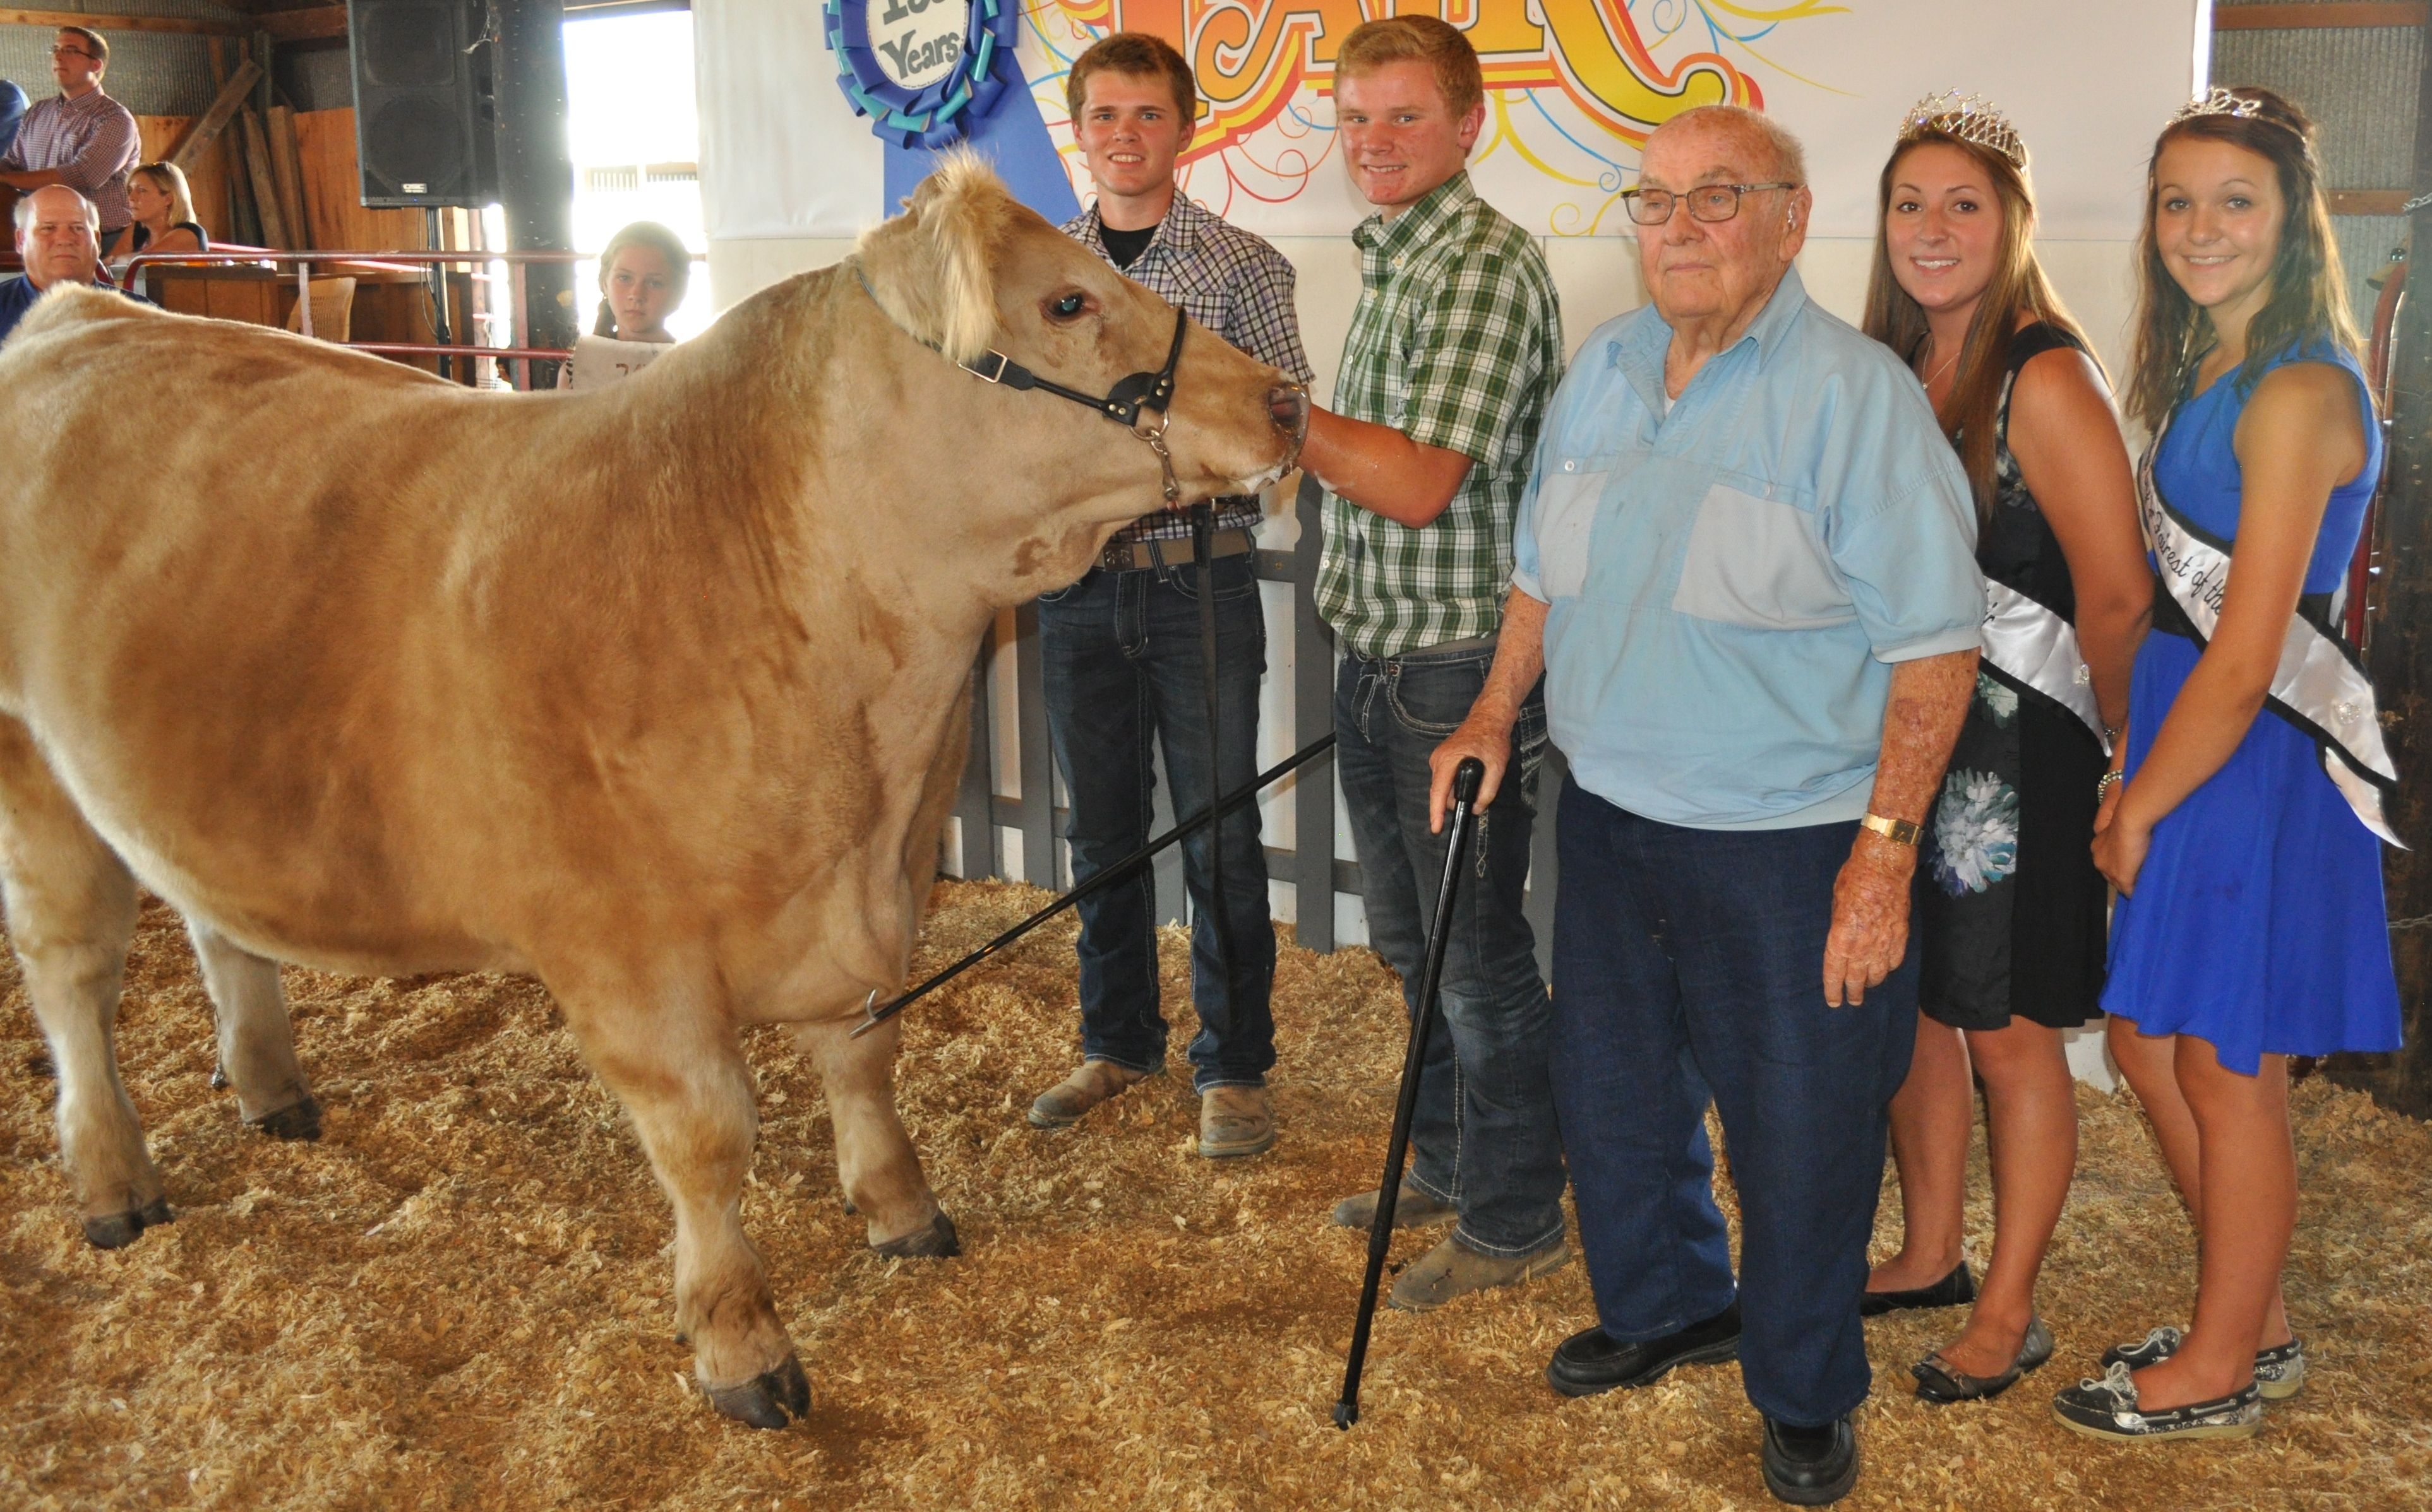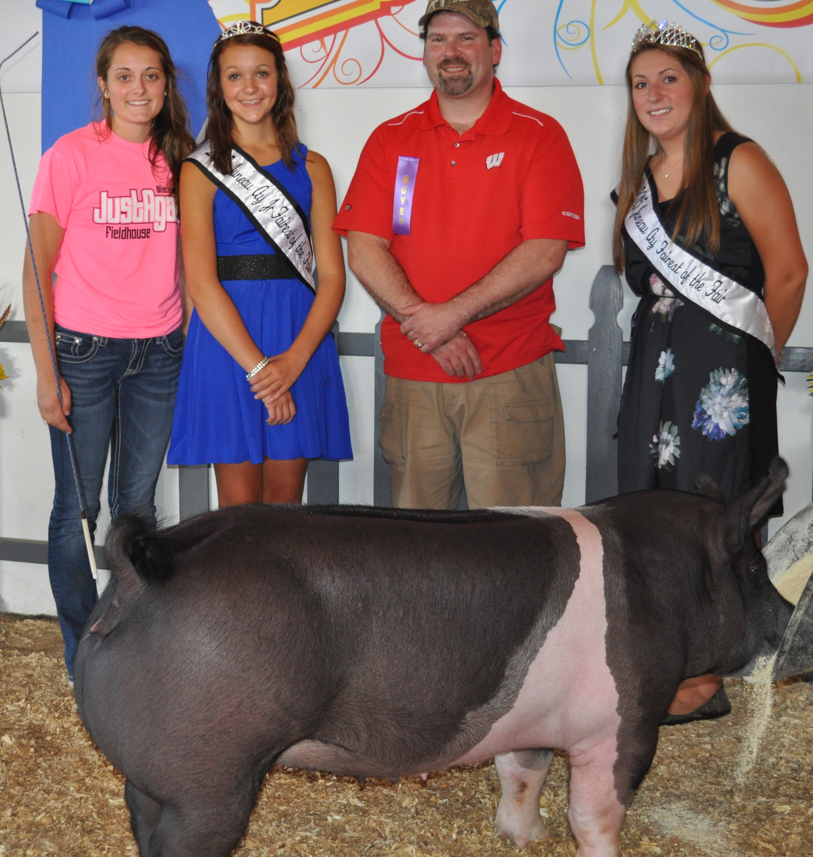
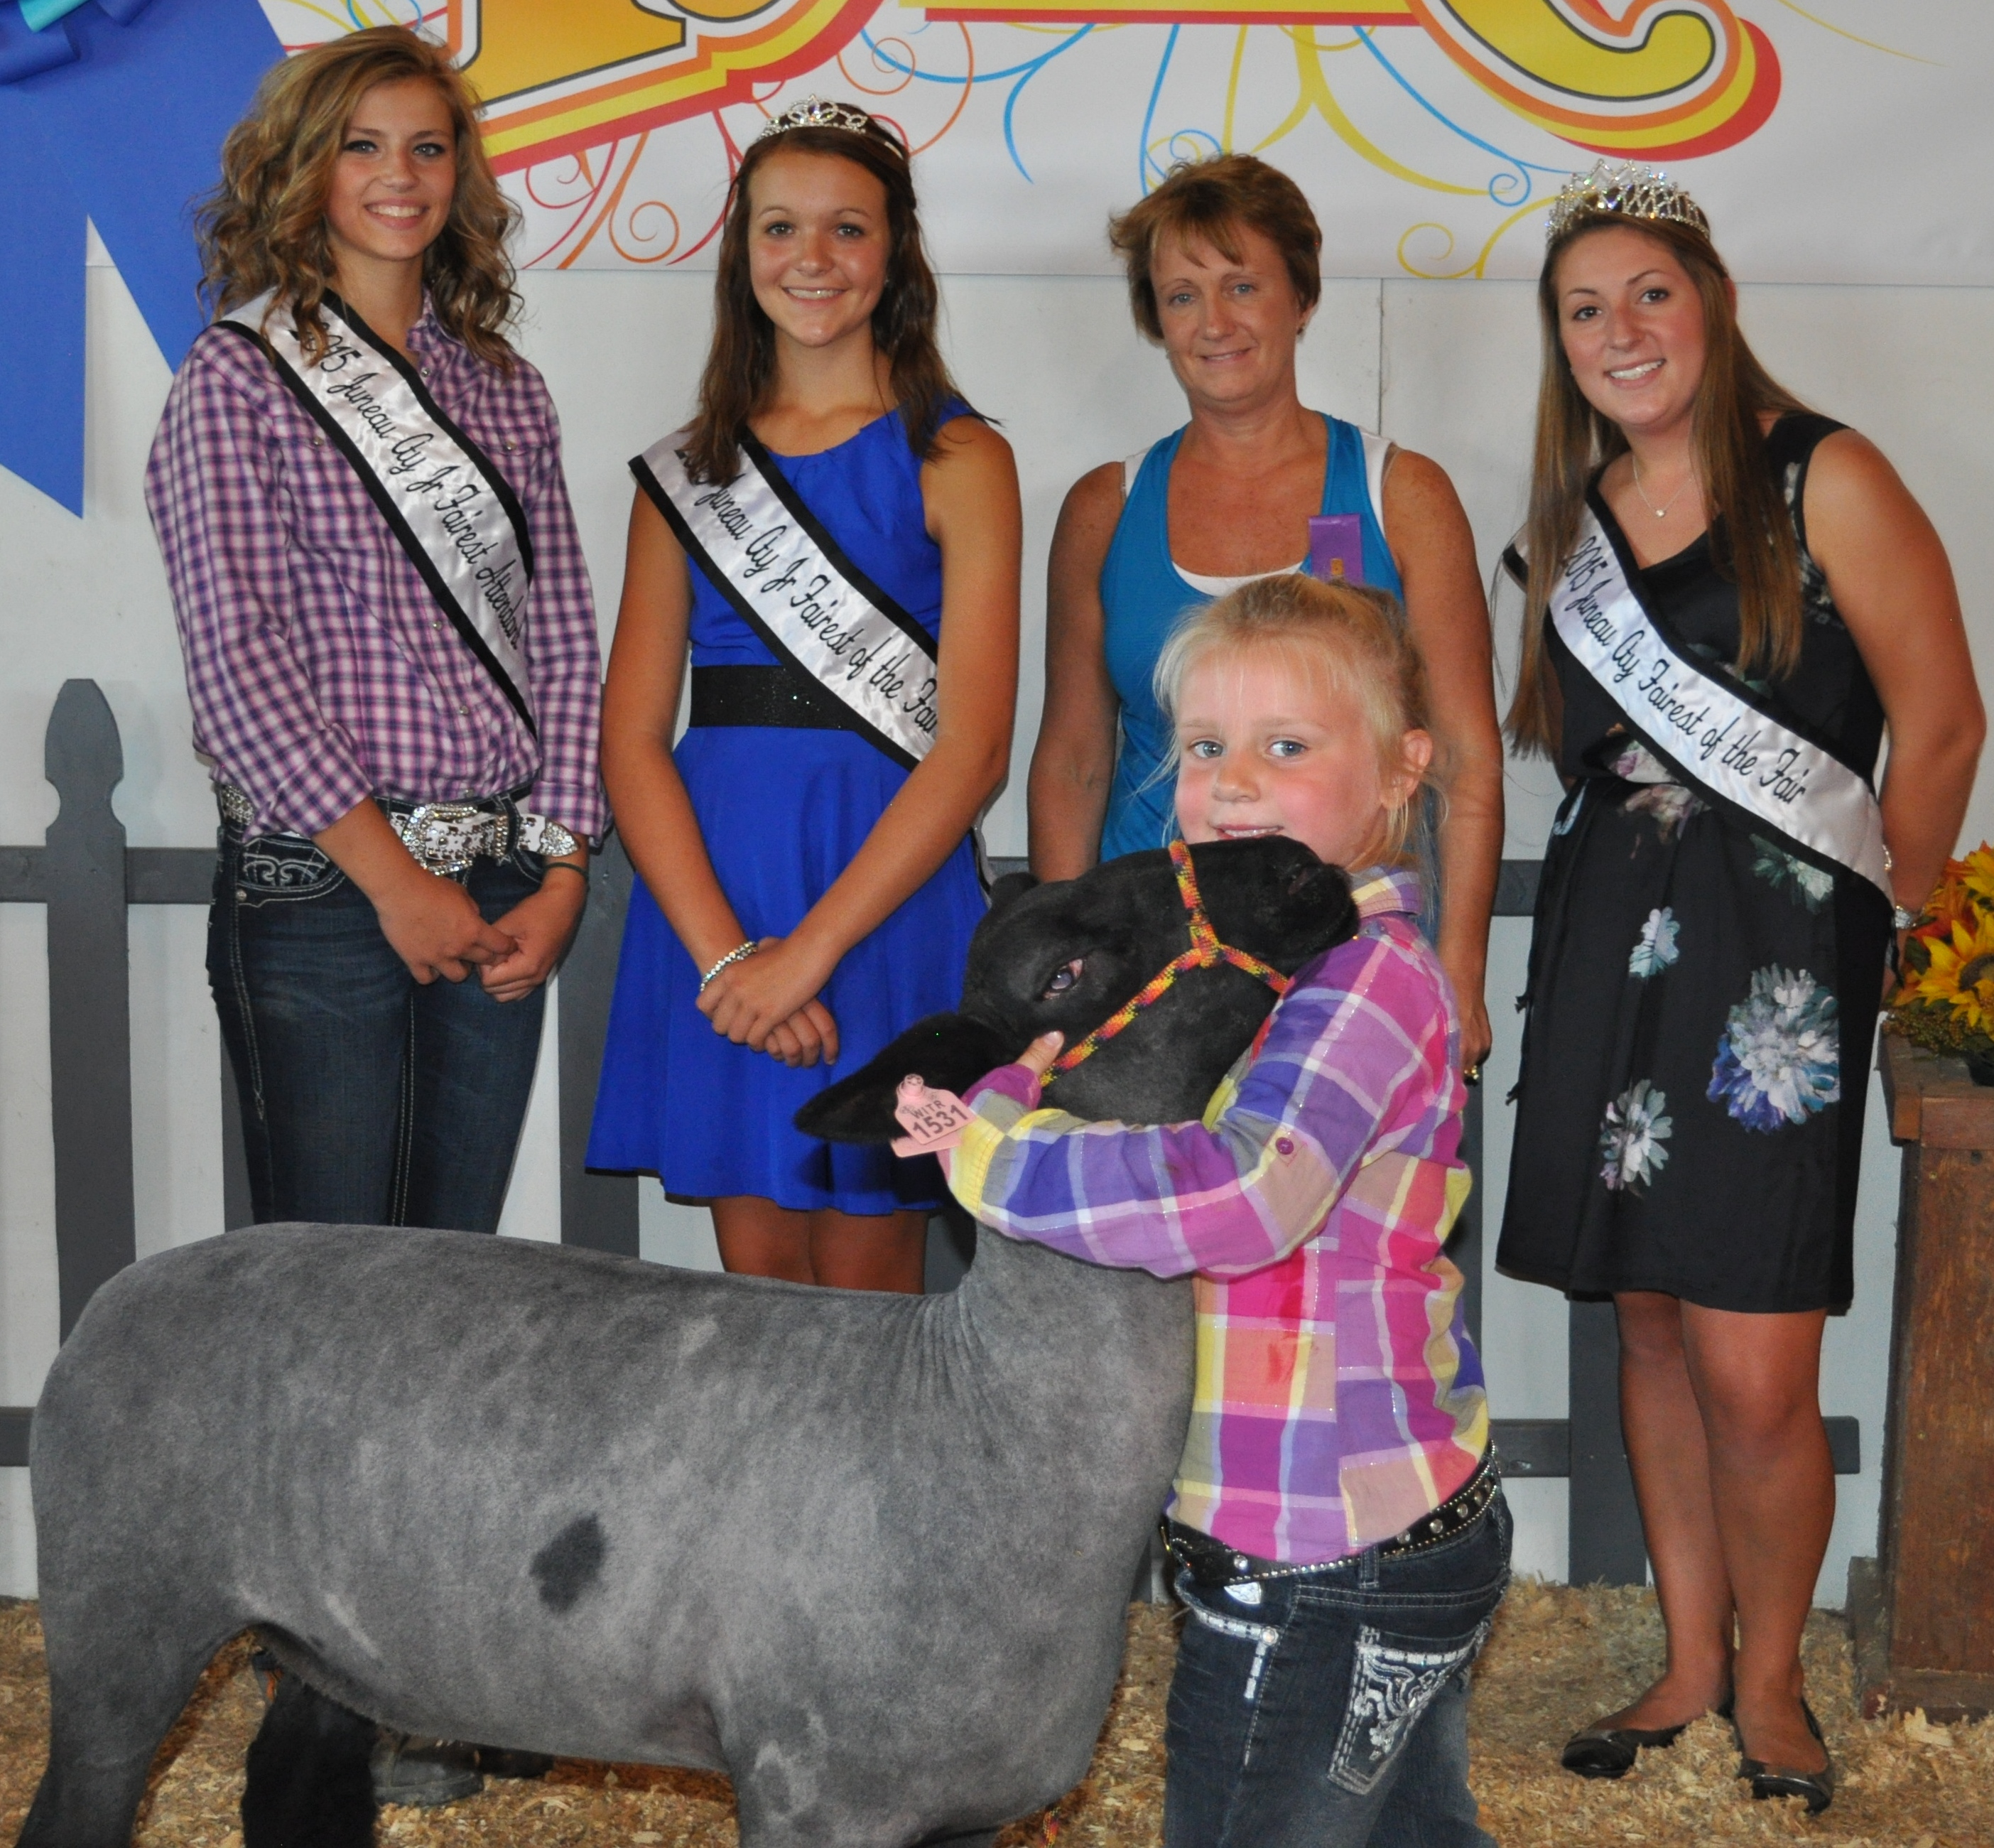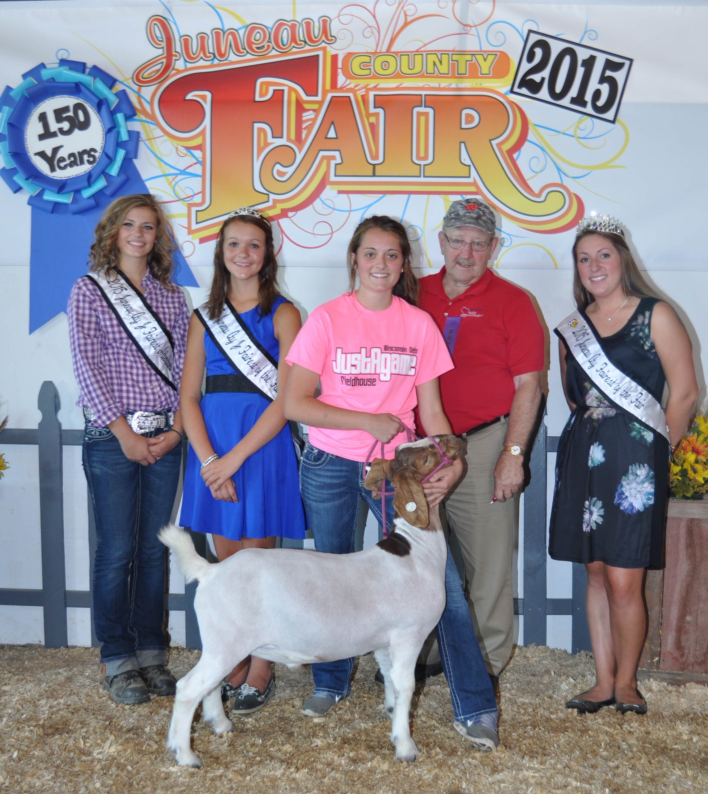
Juneau County Fairgrounds
Mauston WI
August 14-21

Market Sale
Saturday, August 20, 2016
Registration & Presale Social – 2:00 p.m.
Sale Time – 3:00 p.m.

WELCOME, BUYERS!

The Juneau County Livestock Show and Sale is a project coordinated by a committee of volunteers. We hope that our sale is of interest to you and that this booklet answers some of the questions you may have concerning the Show and Sale.

We hope to see you at our auction, if not as a buyer or bidder, then being there to support our program would be greatly appreciated.

Remember, the sale offers FFA and 4-H members a chance to sell the animals they’ve raised all year as part of their Livestock projects.

THIS SALE IS AN OPPORTUNITY
FOR YOU TO:

- Support Juneau County 4-H & FFA youth enrolled in the market animal projects

- Advertise your business (Media Coverage)

- Procure high quality home-grown meat for your freezer

An EEO/Affirmative Action employer, University
An EEO/Affirmative Action employer, University of Wisconsin-Extension provides equal opportunities in employment and programming, including Title IX and ADA requirements.
An EEO/Affirmative Action employer, University of Wisconsin-Extension provides equal opportunities in employment and programming, including Title IX and ADA requirements.
An EEO/Affirmative Action employer, University of Wisconsin-Extension provides equal opportunities in employment and programming, including Title IX and ADA requirements.
of Wisconsin-Extension provides equal opportunities in employment and programming, including Title IX and ADA requirements.

SALE PROVISIONS
FOR POTENTIAL BIDDERS ARE:

- Register at sales ring (no obligation)

- Bidding on animals are based on price per pound

- Care of animals is responsibility of exhibitor until the animals are loaded out on Sunday.

- Accounts to be settled with sales clerk
at the conclusion of the sale.

- All successful bidders will receive a picture of their purchase shown by the exhibitor

- Additional information available at sales desk

- Weight of animal will be as of fair entry date

- Arrangements for slaughter and transportation to area processors are available and need to be made directly after the sale

If you have further questions, contact:
UW-Extension, Mauston at
(608) 847-9329

AFTER THE SALE

After the sale steers, hogs and sheep are returned to the barns, and cared for by the exhibitors. When the fair closes, the animal can be taken care of in several ways. Whatever your choice, please advise the Livestock Committee. If you:

- are keeping the meat for your own use, you
should indicate where the meat will be processed and the Livestock Committee will carry out your instructions for trucking the animal.

- do not plan to keep the meat, you may want to ship the animal to a livestock market to be sold at market price. The Livestock Committee will help you make these arrangements. In a few days you will receive a check from the stockyards for the market price of the animal.

- selected the price support option during the sale and only paid the difference over and above the market price, the animal is returned to the exhibitor and they will be responsible for trucking and marketing the animal.

These choices are listed on the sales slip, presented to the buyers immediately after an animal is sold. Buyers are asked to indicate their choices on the slip, and add any instructions.

Other Options for Purchased Animals

- Co-purchase an animal with another buyer and divide the meat after slaughter
- Give as prizes at company dinners, picnics, or parties
- Donate to community hospitals, senior citizens, homes, etc.

