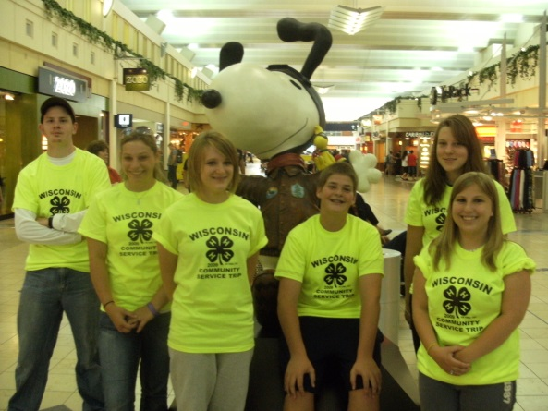
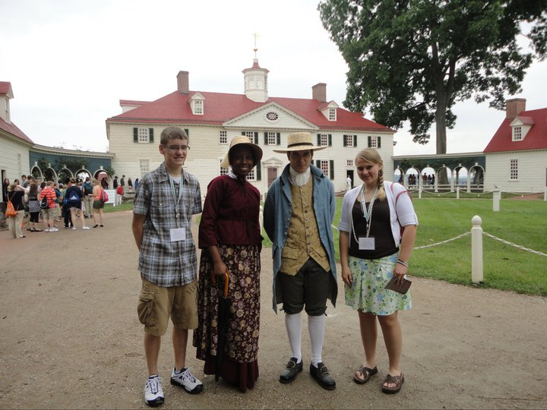

The Citizenship Washington Focus trip Delegates to the Out-of-State Service
experiences living history at Mount Learning Trip to Rhode Island at MSP
Vernon. International Airport.

Guide to Creating an Application and Cover Letter for
4-H Award Trips and the World Beyond!

THE FINAL PRODUCT!
WHAT YOU WILL RETURN TO THE UW-EXTENSION OFFICE BY NOVEMBER 17

- A 4-H Award Trip Preference Form.
- A Trip Promotional Requirement Form and/or Trip Talk Form if a traveler in 2016
- A Cover Letter.
- One letter of recommendation from any adult except a relative.

Guide to Creating an Application and Cover Letter for 4-H Award Trips
Table of Contents: Page
Overview of 4-H Trips and Opportunities 2-3
Pierce County 4-H Leaders Council 4-H Award Trip Policies 4
Self-Evaluation Checklist 5-6
Tips for Creating Cover Letter 7
Main Parts of a Cover Letter 7
List of Action Words to Utilize in Cover Letters and Record Books 8
Sample Cover Letter 9
FORMS
4-H Award Trip Preference Form 10
Adult Recommendation 11
Trip Promotional Requirement Form (required for 2016 Trip Winners) 12

NOTE: If you have questions regarding what is expected or how to complete the application, please call the UW-Extension Office (715-273-6781) or email Frank Ginther (francis.ginther@ces.uwex.edu). We will be happy to set up a time to help you with your application!

LOOK at the Opportunities
which await you...
Now that you have recently completed a 4-H club year, I hope that you are planning to return for an exciting new 4-H year filled with many opportunities, especially for our older 4-H youth.

A variety of opportunities exist for Pierce County 4-H older youth. These opportunities are shared with you in hopes that you will consider getting involved.

Each year, the Pierce County 4-H Leaders’ Council sponsors a variety of award trips available only to our 6th -13th graders. To be considered for any one of the trip and award possibilities, you MUST complete the
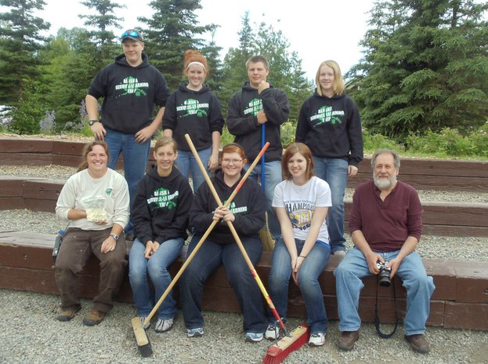
Trip Preference form, Trip Promotional Requirement form (if you traveled last year), Cover Letter, and acquire 1 adult recommendation by November 17. This is used for FIVE (7th & 8th grade Adventure), State 4-H & Youth Conference, American Spirit, Out-of-State Service-Learning, Citizenship Washington Focus, National Congress, and nominations for any other national trips. After a 4-H record book is completed and the 4-H Cover Letter is accepted in to the UW-Extension Office, continuing nominees will be invited to Interviews for the trip and award selection. Bring your Record Book to the Interview if chosen. Interviews will be held late-November.

Remember...you will not know how far you could have gone or what you could have received until you try. Good Luck!!

We are looking for interested older youth to be considered for something special!
Service Learning trip delegates at Campbell Creek Science Center in Anchorage
Don’t miss out on opportunities which await you!!
.

AWARD TRIPS FOR PIERCE COUNTY 4-H OLDER YOUTH:
Trip | Description | Dates & Cost to Delegates
FIVE – 7th & 8th Grade Adventure Trip  (Finding Interesting Varieties in Everyone)  Grades 7-8 | FIVE diversity trip delegates enjoy learning about multiculturalism (appreciating different cultures) in a diverse location closer to home. This Midwest regional trip introduces current school year 7th and 8th graders to concepts of diversity, regional culture, acceptance, and tolerance of other individuals. | The travel takes place in late June or early July depending on delegate schedules.  Approximately $200 for registration & transportation
WI State 4-H Youth Conference  Grades 8-10 | 4-H members from around the state learn about the University of Wisconsin-Madison campus and take part in seminars to learn more about themselves, future careers, and government. | June 26-29, 2017 (confirmed)  About $175 for registration & transportation, not including any seminar fees
Citizenship - Washington Focus  Washington DC  Grades 10-12 | Participate in seminars on citizenship, leadership, government, and civic responsibility. Tour historic sites and meet with Senators and Congressmen. | June 17-25, 2017  June 24-July 2, 2017  July 8-16, 2017  (Sat – Following Sun)  Approximately $650 for registration & transportation.
National 4-H Congress  Atlanta, GA  Grades 11-13 | Must be currently in eleventh grade or above, enrolled in 4-H, have completed at least four years of club work, submitted cover letter, one adult recommendation, and completed a record book and a trip interview. Delegates participate in self-development seminars, tours and a service project, while exchanging ideas with youth from across the country. | November 24-28, 2017  (Fri – Tues)  Approximately $300
Out-of-State Service Learning  Grades 9-12 | This trip will be an experience, with 4-Hers traveling to another state or province and learning about a new culture through travel and service. Members must have completed three years of club work and be in grades 9-12. Travel is in conjunction with 3-4 area counties. The 2015 destination is to tbd. | Travel takes place in late June to early July depending on delegate schedules.  Approximately $600-$800 for registration & transportation
Space Camp  Grades 6-8 | 4-H Missions in Space is a fun filled extended weekend in April at the U.S. Rocket and Space Center in Huntsville, Alabama where participants will complete a simulated Space Shuttle mission, experience training simulators, and learn about becoming an astronaut. | April 20-14, 2017 (Thurs – Mon)  Approximately $300 for registration & transportation.
National 4-H Conference  (Washington DC)  Grades 10-12 | Final selection made by State 4-H Office. Must be currently in eleventh grade or above, enrolled in 4-H, have completed at least four years of club work, submitted cover letter, one adult recommendation, and completed a record book and a trip interview. Six total Wisconsin 4-H youth are selected to attend this working conference held at the National 4-H Center, Washington, D.C. Each participant selects an issue and works with other youth from across the country to develop plans to help direct future 4-H programming. One day is spent on Capitol Hill meeting with legislators and touring. | March 24-30, 2017 (Fri-Thurs)  Approximately $300
American Spirit  Grades 8-10 | A Northwest Region bus travel experience to Amish Country in Pennsylvania, New York City, Plymouth Rock, Boston and Niagara Falls. Youth will be responsible for conducting a teachable moment about a topic related to American history, learn about the many steps taken to gain the U.S. independence and freedom and gain a better understanding of America’s heritage. | Early to mid-June 2017  Approximately $700 plus the cost of a passport for travel to Canada
Unless noted, all Application Materials are due November 17 to the UW-Extension Office.
Pierce County 4-H Leaders’ Council Award Trip Policy

4-H Trip Application Process/Requirements

- Materials Due to Extension Office by November 17 *unless otherwise noted*
- Cover Letter
- One Adult Recommendation
- Trip Preference Form
- Trip Promotional Requirement Forms (if you traveled last year)

- Trip interviews will be conducted in the month of November.
- Bring your completed 4-H Record Book along to the interview.
- Candidates will be notified by December 31 of Award Trip selections.
- Award Trip candidates who cannot attend Trip Interviews must notify the 4-H Youth Development Agent by November 25 and receive an approved excuse. With an approved excuse, the member is responsible for arranging for the interview to be conducted with the 4-H Youth Development Agent prior to the scheduled interview date.

- Not necessarily all members who apply for a trip with a Cover Letter will be awarded an interview or a 4-H Award Trip. Cover Letters and Record Books are subject to standards of completion. The Cover Letter and Record Book should represent a 4-H member’s best work.

Award Trip Payment:
The Pierce County 4-H Leaders’ Council will offer a portion of a 4-H member’s fee and/or expenses for one award trip per year, for each trip once during their 4-H career. (Must meet requirements specific to each trip in addition to those county requirements listed above).

The UW-Extension Office will send a commitment form to selected participants following interview selections. The commitment form with the member’s signature and his/her parent’s signature along with the specified deposit must be turned in by the posted date. The remaining balance must be paid by the dates set by the 4-H Youth Development Agent. The payments could be several small increments or one large sum closer to the date of travel. In any case, the entire amount of the delegate’s fees must be paid no later than two weeks prior to the trip.

If the member defaults on the trip, after turning in the commitment form, and chooses not to attend, the member is responsible for the entire cost of the trip. If the Leaders’ Council has paid a scholarship portion of the trip and the member defaults on the trip, after turning in the commitment form, and chooses not to attend, the member is responsible to pay that portion back to the Leaders’ Council.

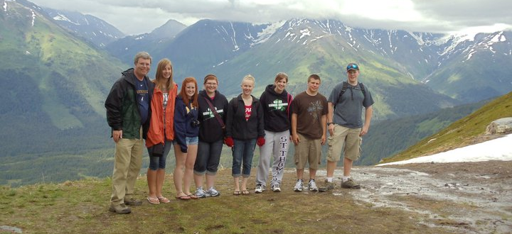
If a member defaults on a trip due to an emergency, for example: death in family, critical illness, divorce, or any other reasonable cause, the Leaders Council has the right to allow default of the trip and no repayment be made.

If a member needs a disciplined plan in making payments, a payment plan may be set up with the 4-H Youth Development Agent in conjunction with the 4-H Adult Advisors Council on an individual case-by-case basis. The payment plan can be kept private.

Out of State Service Learning trip to Alaska.

Pierce County 4-H Award Trip Self-Evaluation Checklist

NOTE: This checklist is not required for application, but can be very helpful. It is simply for you, as the member, to self-evaluate your Cover Letter with the hopes you may discover your own strengths and weaknesses before your application is reviewed by the selection committee.

Name ______________________________ Club______________________________

Please check the box if you agree with the statement. Then, complete the statement at the bottom of the reverse page with specific reasons and details.

Cover Letter
- My Cover Letter is in business letter format with the correct spacing and punctuation.
- My Cover Letter refers to my 4-H Record Book, but does not repeat it.
- My Cover Letter explains my qualifications for being selected for a trip or award.
- My Cover Letter is typed, not handwritten.
- I have described my leadership and commitment to goals in my Cover Letter.
- I go more “in-depth” about my knowledge and skills highlighted in my 4-H Record Book in my Cover Letter.
- My Cover Letter is 1-2 pages long.
- My Cover Letter is arranged in a logical format.
- I used “I” in my Cover letter.
Adult Recommendation
- I provided the adult recommendation form and a pre-addressed envelope to an adult that is not my relative that can speak to my qualifications to receive a trip or award at least two weeks before the form is due.
- I provided the adult with pertinent information about the 4-H Cover Letter and Record Book process.
Overall
- I have completed every component of the Cover Letter thoroughly.
- I was concise, but I also included specific details.
- Unless instructed otherwise, I wrote in paragraphs with complete sentences.
- I feel it is reflective and thoughtful.
- It is representative of my most significant 4-H experiences to date.
- I took time to complete my Cover Letter with care.
- It is an example of my best written communication skills.
- It includes evidence of accomplishments, leadership, improvement, reflection, and learning.
- I know my Cover Letter has few spelling or grammar errors because not only have I proofread it, but so has another trusted adult.

I think the strengths of my Cover Letter are:

__________________________________________________________________________________

__________________________________________________________________________________

__________________________________________________________________________________

__________________________________________________________________________________

__________________________________________________________________________________

__________________________________________________________________________________

__________________________________________________________________________________

__________________________________________________________________________________

__________________________________________________________________________________

__________________________________________________________________________________

__________________________________________________________________________________

__________________________________________________________________________________

My Cover Letter can improve in these ways:

__________________________________________________________________________________

__________________________________________________________________________________

__________________________________________________________________________________

__________________________________________________________________________________

__________________________________________________________________________________

__________________________________________________________________________________

__________________________________________________________________________________

__________________________________________________________________________________

__________________________________________________________________________________

__________________________________________________________________________________

__________________________________________________________________________________

__________________________________________________________________________________

TIPS FOR CREATING YOUR COVER LETTER

Use a computer. You can save your work and make revisions as necessary. This is especially helpful for future use. The cover letter and envelope should not be handwritten.

Plan ahead. Go through each part of the cover letter before typing. Use your old record books to help you. Put your thoughts together. Translate your skills into action oriented, concise, descriptions. As much as possible, think of your 4-H experience as a job. What do you do? What skills have you developed as a result of participation in 4-H? How have you personally changed as a result of your 4-H experience?

Layout, design, and formatting. Your cover letter should be easy to read and understand. Choose an appropriate font and font size. Use the same 1-2 fonts throughout your document. As a general rule, a 1” margin is used at the top, bottom and on both sides of your page. Use action words and be short, concise and to the point. Logical arrangement is very important in a cover letter!

Editing. Your documents should be free of spelling and grammar errors. Use spelling and grammar check and follow that up by having at least two adults proofread your cover letter. Do not use contractions, abbreviations, or 4-H jargon.

Individualize it. This is YOUR cover letter; add your own personality to it. This provides you the opportunity to express emotion, which is evident in a good cover letter. In addition, this is a great way to tailor your cover letter for this particular application.

Put it ALL down. Don’t be modest or shy about your accomplishments and experiences. A cover letter is your chance to highlight your unique skills and qualities. Assume your reader does not know you; provide as complete a description of accomplishments as possible. Remember, accomplishments are about what you have learned, how you have grown, what skills you have developed and what you have experienced, not about awards or ribbons. The accomplishments you discuss in your cover letter should refer to your 4-H Record Book, not repeat it. In addition, the cover letter should explain your accomplishments and experiences in a story-like format that works with the information provided in your 4-H Record Book. This allows you to go in-depth about important knowledge and skills and relate them to the expectations of the “employer” and provide a sample of your written communication skills.

Ask for help if you need it. If you haven’t ever gone through this process, you may have questions. Don’t hesitate to ask! The 4-H & Youth Development Educator is more than willing to help. Call him at 715-273-6781 or email him at francis.ginther@ces.uwex.edu.

MAIN PARTS OF A 4-H AWARDS TRIP COVER LETTER
DATE Date you are mailing letter
ADDRESS Inside address (Address of the individual receiving letter).
SALUTATION Greeting to individual receiving letter, followed by a colon
PARAGRAPH 1 What are you sending and why are you sending it? Include by outlining your objective (i.e., Receive a trip or award).
PARAGRAPHS 2 & 3 This is the “why me?” paragraph. Explain in no more than two paragraphs why you are uniquely qualified to represent Pierce County 4-H. Ask yourself what distinguishes you from other applicants. Give specific examples to help explain your statements.
FINAL PARAGRAPH Thank the Committee for considering your application and request an interview.
CLOSING Sincerely” is the most appropriate closing, followed by a comma
Signature in black pen; should be legible
NAME Typed name that matches signature

List of Action Words to Utilize in Cover Letters and Record Books

Accelerated
Acted
Accomplished
Achieved
Adapted
Administered
Advised
Analyzed
Arranged
Assembled
Assisted
Assumed responsibility
Budgeted
Balanced
Blazed
Billed
Built
Carried out
Changed
Calculated
Channeled
Collected
Communicated
Compiled
Completed
Conceived
Conducted
Controlled
Counted
Compared
Contracted
Coordinated
Counseled
Created
Defined
Delivered
Delegated
Demonstrated
Designed
Determined
Developed
Directed
Dispatched
Distributed
Documented
Earned
Edited
Effected
Eliminated
Enabled
Enforced
Examined
Experimented
Energized
Established
Evaluated
Expanded
Expedited
Facilitated
Found
Functioned as
Gained
Gathered
Generated
Graded
Graduated
Illustrated
Increased
Influenced
Implemented
Improved
Initiated
Innovated
Installed
Instructed
Interpreted
Interviewed
Introduced
Invented
Issued
Judged
Kept
Learned
Listened
Launched
Led
Modeled
Maintained
Managed
Mastered
Met with
Modernized
Motivated
Negotiated
Observed
Operated
Obtained
Optimized
Originated
Orchestrated
Ordered
Organized
Oversaw
Participated
Performed
Pinpointed
Planned
Prepared
Presented
Produced
Programmed
Proved
Provided
Published
Presented
Promoted
Publicized
Questioned
Recommended
Recorded
Recruited
Reduced
Referred
Reinforced
Represented
Researched
Revamped
Reviewed
Revised
Revitalized
Scheduled
Showed
Served
Set up
Solved
Spearheaded
Steered
Studied
Structured
Suggested
Supervised
Supported
Surpassed
Taught
Tested
Trained
Updated
Utilized
Used
Won
Wrote

SAMPLE COVER LETTER

November 2, 2008

Pierce County 4-H Leaders’ Association
412 West Kinne St.
Box 69
Ellsworth, WI 54011

Dear 4-H Leaders’ Council:

It is my pleasure to submit my trip preference form, trip promotional requirement form, and adult recommendation in consideration as a delegate for the Citizenship Washington Focus Trip. My leadership experiences and my dedication to personal development make me a first-rate choice to represent Pierce County 4-H.

I believe my seven years of 4-H experience has prepared me well for representing the Pierce County 4-H program. Not only am I an active member in my 4-H club, but I have demonstrated that I am a sound leader on the county level by accepting several leadership roles like that of the Pierce County 4-H Older Members Reporter and a 4-H Summer Camp Counselor. In these roles, I developed new goal-setting strategies, strengthened my planning and organizing skills, and gained new perspective about myself and others, all of which have made me both a better leader and well-rounded citizen.

Additionally, serving as a 4-H & Youth Conference delegate last year is just one illustration of my commitment to learning in 4-H. While at Conference, I challenged myself by registering for a seminar that would cultivate my viewpoint on diversity issues and, then, following the conference I presented new knowledge with my fellow youth leaders. As a result, my fellow youth leaders and I decided to help plan a diversity seminar for the Youth Engaged in Learning about Leadership (YELL) Conference this year and many of the participants responded that they, too, learned a lot from our seminar.

In closing, I hope to be a Pierce County delegate to Citizenship Washington Focus to learn more about 4-H and to meet diverse people. My previous experience representing Pierce County, as well as my enthusiasm and my eagerness to share what I learn with others makes me a great candidate for this award trip. Thank you for considering my application. Please call me at 555-111-7777 or email me at chris.clover@net.net to schedule an interview. I look forward to discussing my qualifications and my 4-H Record Book with you in person.

Sincerely,

Chris Clover

4-H Award Trip Preference Form

Name: _____________________________________________ Age: ____________________

Club: ___________________________________ Grade entering this fall: _______________

IMPORTANT NOTE: Give careful consideration to the award trips you apply for. When it is time to register for the trip, you will be informed and may be held financially liable for part of the cost if you cancel after payments are due.

Please check the appropriate boxes – PUT AT LEAST ONE CHECK FOR EVERY TRIP.

Trips: | I have received this award in the past | I would like to apply this year. | I don’t want to apply this year.
FIVE – 7th & 8th Grade Adventure Trip (Finding Interesting Varieties in Everyone) (Gr. 7-8)
WI State 4-H Youth Conference (Madison – Grade 8-10)
Citizenship - Washington Focus (Washington DC – Gr. 10-12)
National 4-H Congress
(Atlanta, GA – Grade 11-13)
Out-of-State Service Learning
(Grade 9-12)
American Spirit
(Grade 9-10)
Space Camp
(Grade 6-8)
National 4-H Conference
(Washington DC)
final decision made by State 4-H Office
Comments:
____________________________________________________________________________

____________________________________________________________________________

PIERCE COUNTY 4-H
ADULT RECOMMENDATION

The following applicant ___________________________________ is applying to represent the Pierce County 4-H program on an out-of-county trip and/or to be selected as a 4-H Award recipient. You have been identified as a person who could speak to their qualifications for these trips and awards. It is the responsibility of the youth leader to see that you receive this recommendation at least 1 week prior to the due date along with a pre-addressed envelope. Recommendations are confidential and will not be returned to the 4-H youth leader. A recommendation from a family member will not be accepted.

Please complete the following recommendation and return as directed below.

- Today’s Date Completed: ___________________ Name: ________________________________

Phone: ________________________ Email: __________________________________________

Do you feel this member would be a good representative of Pierce County 4-H if selected as a delegate on a 4-H trip, or as a Key Award winner? ____ Yes _____ No

How long have you known this 4-H member? _____________________________________________

In what capacity do you know this member? ______________________________________________

Evaluate the Member | Poor | Fair | Good | Excellent | N/A
Involvement in 4-H at Club level
Involvement in 4-H at County level
Involvement in School & Community
Works to the best of their ability
Dependability
Communication
Leadership Skills
Ethics
Solving Problems
Independence and Maturity Level

- Comments:

Signature of Adult Recommending 4-H Youth Leader: ___________________________________
Recommendations should be sent directly to:
Pierce County UW-Extension Office
4-H Trip and Award Recommendation
412 S. Kinne St.; BOX 69
Ellsworth, WI 54011
DEADLINE DATE: November 17

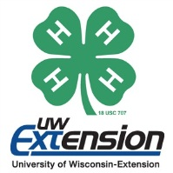
Pierce County 4-H Leaders’
Trip Promotional Requirement Form

The Pierce County 4-H Leaders’ Council will offer a portion of a 4-H member’s fee and/or expenses for one award trip per year, for each trip once during their 4-H career. In return, trip recipients are expected to work an assigned shift in the Food Stand during the County Fair, help promote 4-H and the available trips, and complete two annual Trip Talks. Trip winners are also encouraged to create and display one 4-H marketing item such as a poster, scrapbook, or news release and to actively participate in other countywide approved fundraising such as Platbook Ad sales or Adopt A Pen efforts. If a member cannot complete a requirement, s/he must establish an alternative with the 4-H Agent. Trip recipients who do not complete these requirements will be ineligible for future trips or awards and will be held responsible for reimbursement of funds contributed by the 4-H Leaders’ Council toward their trip.
Trip recipients must complete requirements 1-3 below or establish an alterantive plan with the 4-H Agent. Pledges 4 and 5 are strongly encouraged. When you complete a requirement, write the date in the blank provided and ask an adult from the place where you went to sign the form as a record that the requirement was completed.
In return for the 4-H Leaders’ Association  Financial Support, I… | Date |  |  | Signature
- Completed a 4-H Record Book
- Worked in Food Stand at County Fair
- Talked at 2 4-H Clubs or other county-wide meeting to promote the 4-H Award Trip program (May also put in anticipated dates of 2016-17 Trip Talks) | 1 |  |  | 1
 | 2 |  |  | 2
- Created and displayed/published one 4-H marketing item such as a news release, poster, display, etc.
- Actively participated in one countywide, pre-approved fundraising event, in addition to the fair food stand
DUE BY NOVEMBER 17 if you traveled on a 4-H Award Trip in 2016

