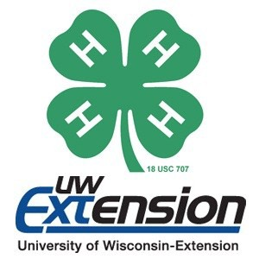
Northwest WI
4-H Horse Educational Contest
March 4, 2017
UW-River Falls Agricultural Science Building
611 S 3rd St, River Falls, WI 54022
Guest Speaker will be featured
Topic: Equine Reproduction
Check-in: 8:30 am
Contest: 9:00 am Competitions offered:

- Horse Bowl
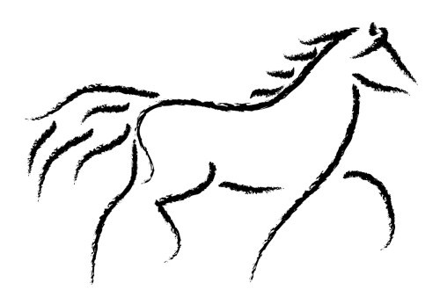
- Hippology
- Posters
- Drawings
- Photography

Registration (fees payable in advance or at the door)
Deadline for entries: February 20
Return to: Pierce County UWEX, 412 West
Kinne St., Box 69, Ellsworth, WI 54011

Questions:
Contact Stephanie Rohl, Pierce County 4-H Horse Project Volunteer at jjrohl6@gmail.com OR call
715-760-1618

