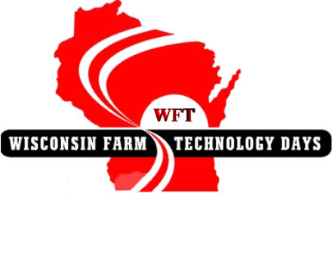
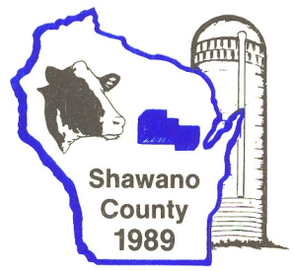
Shawano County
Farm Progress Days
Scholarship

BACKGROUND
In 1989, Shawano County hosted Wisconsin Farm Progress Days at the Rosenow and Schmidt Farms in Shawano. The three-day event was the largest agricultural show in Wisconsin and one of the largest in the nation.
The event showcased the latest improvements in agricultural production, including many practical applications of recent research and technological developments.
Farm Progress Days, chaired by Vernon Ainsworth, was a tremendous success in all respects and a tribute to the local volunteerism and community support that made it possible.
This successful event generated earnings, which made it possible for local sponsors to fund several community projects and initiatives — including this scholarship fund.

PURPOSE
The Shawano County Farm Progress Days Scholarship Fund, a component fund of the UW System Trust Fund Endowment Scholarship, was established to promote continuing educational opportunities in the field of agriculture and to provide educational opportunities during various stages of an individual’s life and/or career.
Scholarships are available to qualified persons who are enrolled in a degreed program, short course, or continuing education program within the University of Wisconsin, including 2 and 4 year campuses as well as the Dairy Short Course at UW-Madison. This could include the study of Agribusiness Management, Genetics, Landscape Architecture, Biochemistry, Bacteriology, Food Science, Horticulture, Environmental Sciences, Agricultural Journalism, Ag Mechanics or other related fields of agricultural study.

CRITERIA FOR SELECTION
The following criteria will be used in determining the recipients of scholarship funds. The applicant must:
- Be a Shawano County resident, or currently studying at a high school within Shawano County.
- Possess above average potential for successful work in the agricultural industry as indicated by past record, test data, and other supplemental information.
- Provide evidence of related educational achievement.
- Demonstrate good character, good citizenship, and leadership.
- Demonstrate a record of active participation in extracurricular activities.
- Evidence of other circumstances such as family, financial, or personal challenges (including number of family members currently pursuing higher education) which make an applicant more worthy of consideration may also be provided.

APPLICATION PROCESS
To be considered for this scholarship award, the following items must be received in the Shawano County UW-Extension office by the April 15:
- A completed scholarship application form
  - available from Shawano County UW-Extension office or online at http://shawano.uwex.edu/ag
- Two letters of reference (at least one from a teacher or counselor).
- Proof of enrollment in an agricultural field of study in the University of Wisconsin (if available).
- Your most recent transcript of grades for upperclassman application. (A copy is permissible)
Application form:
- Shawano County Farm Progress Days Application for FRESHMAN
- Shawano County Farm Progress Days Application for UPPERCLASSMAN
The Shawano County Farm Progress Days Scholarship committee will review the applications. All applicants will be notified of the status of their application by the end of May.
PAYMENT
Scholarship funds will be sent by the UW-Trust Fund directly to the school the scholarship recipient is attending.
Due to varying fund growth, scholarship amounts are subject to committee review. Quality applicants could receive up to $2000.
PAST SCHOLARSHIP RECIPIENTS
- 2013 Dylan Payne, Ryan Paschke & Jed Dallas
- 2012 Tyler Hermann, Jed Dallas, Ashley Ainsworth, Kaitlin Fuhrman, & Marissa Bahr
- 2011 Curtis Horsens, Abagael (Abby) Tauchen, Tyler Hermann, & Ryan Horsens
- 2010 Curtis Horsens, Anne Moore, Abagael (Abby) Tauchen & Aly Dallas
- 2009 Kayla Schmidt & Samantha Ainsworth
- 2008 Ben Voelz
- 2007 Megan Fuhrman
- 2006 Heidi Zahn, Stacy Schwartz, Diane Voelz, Sara Vomastic
- 2005 Sara Vomastic
- 2004 Cynthia Voelz
- 2003 Kristopher Clauss
- 2002 Aaron Retzlaff, Rachel Hafferman, Kristopher Clauss,
Jennifer Bjelland, Samantha Bulger & Trisha Hieronimczak
- 2001 Trisha Hieronimczak & Ann Jarek
- 2000 Trisha Hieronimczak
- 1999 Danielle Holewinski, Roy Wilson & Eric Asenbrener
- 1998 Matt Bjelland & Melissa Goers
- 1997 Jami Jo Gast
- 1996 Grant Staszak
- 1995 None Awarded
- 1994 Julie Lemke-Bonnin
- 1993 Kevin Jarek
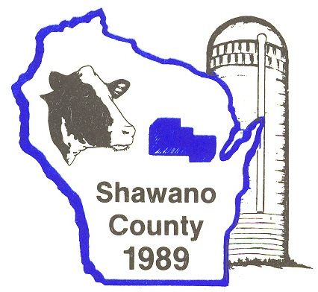
- 1992 Kevin Jarek

