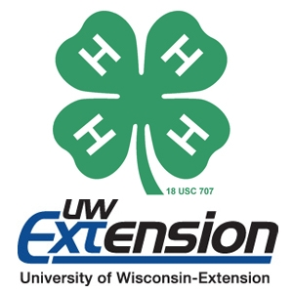
Membership
St. Croix County 4-H
2017 Fact Sheet
St. Croix County 4-H has 677 members enrolled ranging from ages 6 to 19.
Demographics
4-H is an organization for all people from all places. There are all types of activities and projects for everyone!

Volunteers
There are 218 adult volunteers in St. Croix County.
Gender
There are 281 males and 396 females, who participate in St. Croix County 4-H.

4-H Clubs
There are 19 4-H Clubs within St. Croix County. They meet all over the county as seen below.
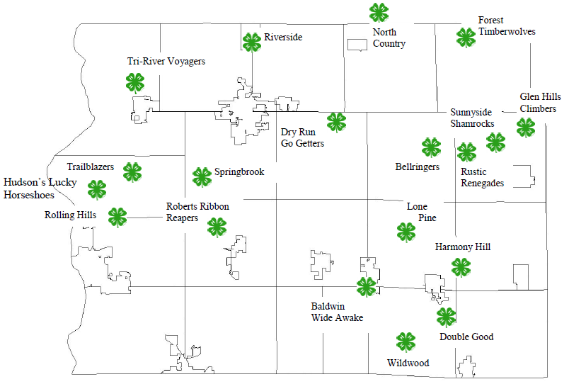
Projects
4-H youth have several projects to choose from, but the most popular are: Dairy, Horse, Drawing & Painting, Foods & Nutrition, Woodworking, and Photography. This year we had 121 youth enrolled in the Cloverbud program, which is our youngest members. This is an amazing statistic because it shows that 4-H in St. Croix County will only be growing!

