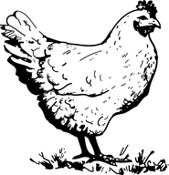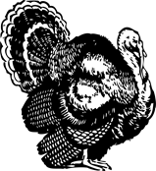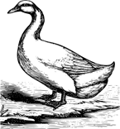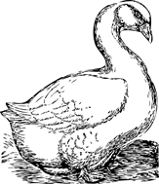
WELCOME TO
WALWORTH COUNTY POULTRY PROJECT
Project Meeting Dates: 12/8/16- 1/19/17-3/16/17-5/18/17-7/20/17-August 2017 TBD Cage Set up
Meetings are held:All Meetings are held @ the Fair Grounds @ 7PM
You can review the Project Guide online at: http://walworth.uwex.edu/4-youth-development/projects/poultry-project/

______________________________________________________________________________Members Name:
Date of Birth:
Contact Information:
Parents Names:
Siblings:
Grade:
Years participated in The Poultry Project?
What are your project interests? Chicken/Turkeys/Ducks/Geese?

Do you have an interest in Showmanship?
What do you expect to take away from this project?

What can the committee assist you with?

Do you have any questions?

