The newest Dietary Guidelines for Americans was developed because more than 1/3 of children and more than 2/3 of adults in the United States are overweight or obese. Improving food choices can decrease the risk of diet-related chronic diseases.

For more information go to www.ChooseMyPlate.gov.
2011


Health
focus

Caring about the
health of our Employees and customers

Keys to maintaining a heathly diet.
The Dietary Guidelines for Americans places emphasis on the following goals:
• Enjoy your food, but eat less.
• Avoid oversized portions.
• Make half your plate fruits and vegetables.
• Switch to fat-free or low-fat (1%) milk.
• Make at least half your grains whole grains.
• Compare sodium in foods like soup, bread, and frozen meals – and choose the foods with lower numbers.
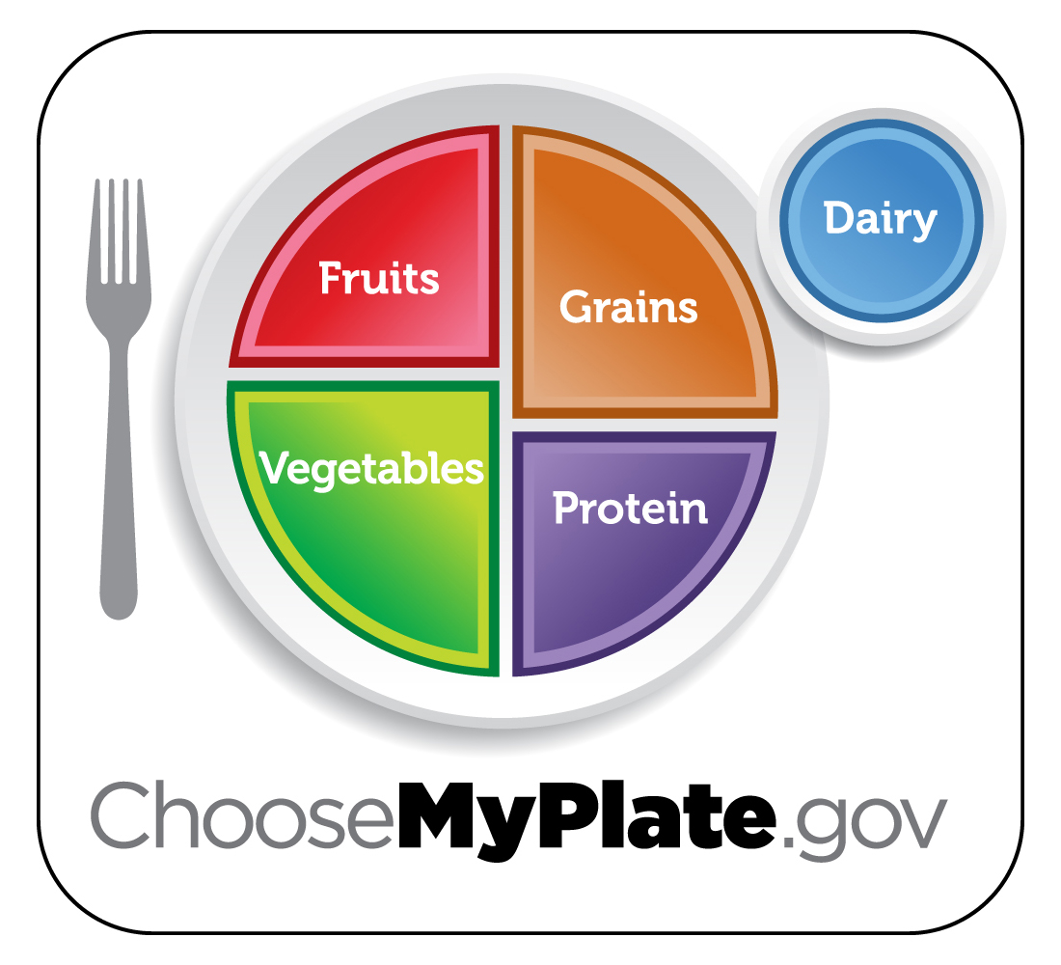
• Drink water instead of sugary drinks.

The newest Dietary Guidelines for Americans was developed because more than 1/3 of children and more than 2/3 of adults in the United States are overweight or obese. Improving food choices can decrease the risk of diet-related chronic diseases.

For more information go to www.ChooseMyPlate.gov.
2011

Health
focus

Caring about the
health of our Employees and customers

Keys to maintaining a heathly diet.
The Dietary Guidelines for Americans places emphasis on the following goals:
• Enjoy your food, but eat less.
• Avoid oversized portions.
• Make half your plate fruits and vegetables.
• Switch to fat-free or low-fat (1%) milk.
• Make at least half your grains whole grains.
• Compare sodium in foods like soup, bread, and frozen meals – and choose the foods with lower numbers.
• Drink water instead of sugary drinks.

The newest Dietary Guidelines for Americans was developed because more than 1/3 of children and more than 2/3 of adults in the United States are overweight or obese. Improving food choices can decrease the risk of diet-related chronic diseases.

For more information go to www.ChooseMyPlate.gov.
2011

Health
focus

Caring about the
health of our Employees and customers

Keys to maintaining a heathly diet.
The Dietary Guidelines for Americans places emphasis on the following goals:
• Enjoy your food, but eat less.
• Avoid oversized portions.
• Make half your plate fruits and vegetables.
• Switch to fat-free or low-fat (1%) milk.
• Make at least half your grains whole grains.
• Compare sodium in foods like soup, bread, and frozen meals – and choose the foods with lower numbers.
• Drink water instead of sugary drinks.

Tips to Build a Healthy Meal:

take your time Savor your food. Eat slowly, enjoy the taste and textures, and pay attention to how you feel. Be mindful. Eating very quickly may cause you to eat too much.

use a smaller plate Use a smaller plate at meals to help with portion control. That way you can finish your entire plate and feel satisfied without overeating.


take control of your food Eat at home more often so you know exactly what you are eating. If you eat out, check and compare the nutrition information. Choose healthier options such as baked instead of fried.

try new foods Keep it interesting by picking out new foods you’ve never tried before, like mango, lentils, or kale. You may find a new favorite! Trade fun and tasty recipes with friends or find them online.

satisfy your sweet tooth in a
healthy way
Indulge in a naturally sweet dessert dish—fruit! Serve a fresh fruit cocktail or a fruit parfait made with yogurt. For a hot dessert, bake apples and top with cinnamon.

ChooseMyPlate.gov DG TipSheet No. 7 June 2011
USDA Center for Nutrition Policy and Promotion

University of Wisconsin, U.S. Department of Agriculture and Wisconsin Counties cooperating.
UW-Extension provides equal opportunities in employment and programming including Title IX and ADA.

Tips to Build a Healthy Meal:

take your time Savor your food. Eat slowly, enjoy the taste and textures, and pay attention to how you feel. Be mindful. Eating very quickly may cause you to eat too much.

use a smaller plate Use a smaller plate at meals to help with portion control. That way you can finish your entire plate and feel satisfied without overeating.

take control of your food Eat at home more often so you know exactly what you are eating. If you eat out, check and compare the nutrition information. Choose healthier options such as baked instead of fried.

try new foods Keep it interesting by picking out new foods you’ve never tried before, like mango, lentils, or kale. You may find a new favorite! Trade fun and tasty recipes with friends or find them online.

satisfy your sweet tooth in a
healthy way
Indulge in a naturally sweet dessert dish—fruit! Serve a fresh fruit cocktail or a fruit parfait made with yogurt. For a hot dessert, bake apples and top with cinnamon.

ChooseMyPlate.gov DG TipSheet No. 7 June 2011
USDA Center for Nutrition Policy and Promotion

University of Wisconsin, U.S. Department of Agriculture and Wisconsin Counties cooperating.
UW-Extension provides equal opportunities in employment and programming including Title IX and ADA.

Tips to Build a Healthy Meal:

take your time Savor your food. Eat slowly, enjoy the taste and textures, and pay attention to how you feel. Be mindful. Eating very quickly may cause you to eat too much.

use a smaller plate Use a smaller plate at meals to help with portion control. That way you can finish your entire plate and feel satisfied without overeating.

take control of your food Eat at home more often so you know exactly what you are eating. If you eat out, check and compare the nutrition information. Choose healthier options such as baked instead of fried.

try new foods Keep it interesting by picking out new foods you’ve never tried before, like mango, lentils, or kale. You may find a new favorite! Trade fun and tasty recipes with friends or find them online.

satisfy your sweet tooth in a
healthy way
Indulge in a naturally sweet dessert dish—fruit! Serve a fresh fruit cocktail or a fruit parfait made with yogurt. For a hot dessert, bake apples and top with cinnamon.

ChooseMyPlate.gov DG TipSheet No. 7 June 2011
USDA Center for Nutrition Policy and Promotion

University of Wisconsin, U.S. Department of Agriculture and Wisconsin Counties cooperating.
UW-Extension provides equal opportunities in employment and programming including Title IX and ADA.

