What counts as an ounce of protein foods?
1 ounce lean meat, poultry, or seafood; ¼ cup cooked beans or peas; ½ ounce nuts or seeds; or 1 tablespoon peanut butter.
From the website of:

From the website of
http://www.cdc.gov/diabetes/pubs/pdf/ndfs_2011.pdf
2011


Health
focus

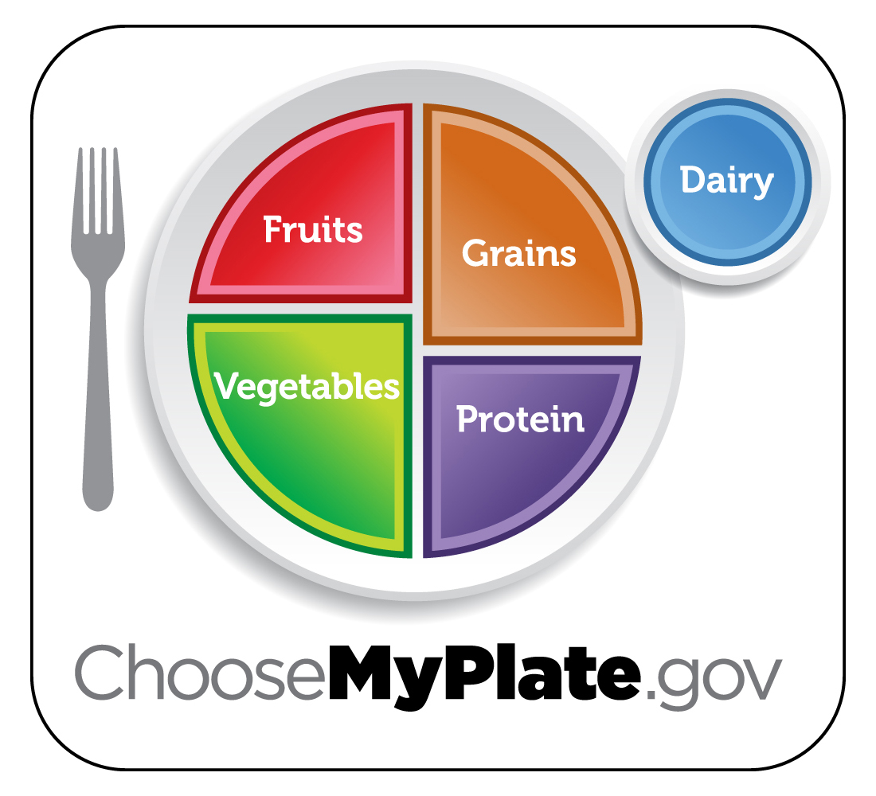
Caring about the
health of our Employees and customers

H
Lentil Chili
Serving Size: 1 cup Yield: 6 servings

Ingredients:
½ pound ground beef (Or extra lean beef to
reduce fat)
1½ cups chopped onion
1 clove garlic, crushed
2 cups cooked, drained lentils
1 can (29 ounce) tomatoes, diced or
crushed
1 tablespoon chili powder
½ teaspoon ground cumin (optional)

Preparation:
1. In a large saucepan, brown beef over medium-high heat, breaking it into bite-sized pieces. Drain fat.
2. Reduce to medium heat. Add onion and garlic. Cook on medium heat, until softened.
3. Add lentils, tomatoes, chili powder, and cumin. Cook on low heat for about 1 hour until flavors are blended.
4. Serve with your favorite chili toppings.

Per Serving:
Calories 210, Total Fat 4.5g, Saturated Fat 1.5 g,
Sodium 470 mg, Protein 16 g

What counts as an ounce of protein foods?
1 ounce lean meat, poultry, or seafood; ¼ cup cooked beans or peas; ½ ounce nuts or seeds; or 1 tablespoon peanut butter.
From the website of:

2011

Health
focus

Caring about the
health of our Employees and customers

H
Lentil Chili
Serving Size: 1 cup Yield: 6 servings

Ingredients:
½ pound ground beef (Or extra lean beef to
reduce fat)
1½ cups chopped onion
1 clove garlic, crushed
2 cups cooked, drained lentils
1 can (29 ounce) tomatoes, diced or
crushed
1 tablespoon chili powder
½ teaspoon ground cumin (optional)

Preparation:
1. In a large saucepan, brown beef over medium-high heat, breaking it into bite-sized pieces. Drain fat.
2. Reduce to medium heat. Add onion and garlic. Cook on medium heat, until softened.
3. Add lentils, tomatoes, chili powder, and cumin. Cook on low heat for about 1 hour until flavors are blended.
4. Serve with your favorite chili toppings.

Per Serving:
Calories 210, Total Fat 4.5g, Saturated Fat 1.5 g,
Sodium 470 mg, Protein 16 g

What counts as an ounce of protein foods?
1 ounce lean meat, poultry, or seafood; ¼ cup cooked beans or peas; ½ ounce nuts or seeds; or 1 tablespoon peanut butter.

From the website of:

From the website of
http://www.cdc.gov/diabetes/pubs/pdf/ndfs_2011.pdf
2011

Health
focus

Caring about the
health of our Employees and customers

H
Lentil Chili
Serving Size: 1 cup Yield: 6 servings

Ingredients:
½ pound ground beef (Or extra lean beef to
reduce fat)
1½ cups chopped onion
1 clove garlic, crushed
2 cups cooked, drained lentils
1 can (29 ounce) tomatoes, diced or
crushed
1 tablespoon chili powder
½ teaspoon ground cumin (optional)

Preparation:
1. In a large saucepan, brown beef over medium-high heat, breaking it into bite-sized pieces. Drain fat.
2. Reduce to medium heat. Add onion and garlic. Cook on medium heat, until softened.
3. Add lentils, tomatoes, chili powder, and cumin. Cook on low heat for about 1 hour until flavors are blended.
4. Serve with your favorite chili toppings.

Per Serving:
Calories 210, Total Fat 4.5g, Saturated Fat 1.5 g,
Sodium 470 mg, Protein 16 g

With protein, variety is key
nuts and seeds
Choose unsalted nuts or seeds as a snack, on salads,or in main dishes to replace meat or poultry. Nuts and seeds are a concentrated source of calories, so eat small portions to keep calories in check.
keep it tasty and healthy
Try grilling, broiling, roasting, or baking—they don’t add extra fat. Some lean meats need slow, moist cooking to be tender—try a slow cooker for them. Avoid breading meat or poultry, which adds calories.
make a healthy sandwich
Choose turkey, roast beef, canned tuna or salmon, or peanut butter for sandwiches. Many deli meats, such as regular bologna or salami, are high in fat and sodium—make them occasional treats only.
think small when it comes to
meat portions
Get the flavor you crave but in a smaller portion. Make or order a smaller burger or a “petite” size steak.
check the sodium
Check the Nutrition Facts label to limit sodium.Salt is added to many canned foods—including beans and meats. Many processed meats—such as ham, sausage, and hot dogs—are high in sodium. Some fresh chicken, turkey, and pork are brined in a salt solution for flavor and tenderness.

Consider this...
Protein in the diet is one of the primary nutrients in the food we eat and provides the "building material" for the growth and repair of tissue and are a key part of every cell in the body.

Sources:
http://www.improving-health-and-energy.com/
ChooseMyPlate.gov DG TipSheet No. 3,7 June 2011
USDA Center for Nutrition Policy and Promotion

University of Wisconsin, U.S. Department of Agriculture and Wisconsin Counties cooperating.
UW-Extension provides equal opportunities in employment and programming including Title IX and ADA.
With protein, variety is key
nuts and seeds
Choose unsalted nuts or seeds as a snack, on salads,or in main dishes to replace meat or poultry. Nuts and seeds are a concentrated source of calories, so eat small portions to keep calories in check.
keep it tasty and healthy
Try grilling, broiling, roasting, or baking—they don’t add extra fat. Some lean meats need slow, moist cooking to be tender—try a slow cooker for them. Avoid breading meat or poultry, which adds calories.
make a healthy sandwich
Choose turkey, roast beef, canned tuna or salmon, or peanut butter for sandwiches. Many deli meats, such as regular bologna or salami, are high in fat and sodium—make them occasional treats only.
think small when it comes to
meat portions
Get the flavor you crave but in a smaller portion. Make or order a smaller burger or a “petite” size steak.
check the sodium
Check the Nutrition Facts label to limit sodium.Salt is added to many canned foods—including beans and meats. Many processed meats—such as ham, sausage, and hot dogs—are high in sodium. Some fresh chicken, turkey, and pork are brined in a salt solution for flavor and tenderness.
Consider this...
Protein in the diet is one of the primary nutrients in the food we eat and provides the "building material" for the growth and repair of tissue and are a key part of every cell in the body.

Sources:
http://www.improving-health-and-energy.com/
ChooseMyPlate.gov DG TipSheet No. 3,7 June 2011
USDA Center for Nutrition Policy and Promotion

University of Wisconsin, U.S. Department of Agriculture and Wisconsin Counties cooperating.
UW-Extension provides equal opportunities in employment and programming including Title IX and ADA.
With protein, variety is key
nuts and seeds
Choose unsalted nuts or seeds as a snack, on salads,or in main dishes to replace meat or poultry. Nuts and seeds are a concentrated source of calories, so eat small portions to keep calories in check.
keep it tasty and healthy
Try grilling, broiling, roasting, or baking—they don’t add extra fat. Some lean meats need slow, moist cooking to be tender—try a slow cooker for them. Avoid breading meat or poultry, which adds calories.
make a healthy sandwich
Choose turkey, roast beef, canned tuna or salmon, or peanut butter for sandwiches. Many deli meats, such as regular bologna or salami, are high in fat and sodium—make them occasional treats only.
think small when it comes to
meat portions
Get the flavor you crave but in a smaller portion. Make or order a smaller burger or a “petite” size steak.
check the sodium
Check the Nutrition Facts label to limit sodium.Salt is added to many canned foods—including beans and meats. Many processed meats—such as ham, sausage, and hot dogs—are high in sodium. Some fresh chicken, turkey, and pork are brined in a salt solution for flavor and tenderness.
Consider this...
Protein in the diet is one of the primary nutrients in the food we eat and provides the "building material" for the growth and repair of tissue and are a key part of every cell in the body.

Sources:
http://www.improving-health-and-energy.com/
ChooseMyPlate.gov DG TipSheet No. 3,7 June 2011
USDA Center for Nutrition Policy and Promotion

University of Wisconsin, U.S. Department of Agriculture and Wisconsin Counties cooperating.
UW-Extension provides equal opportunities in employment and programming including Title IX and ADA.

