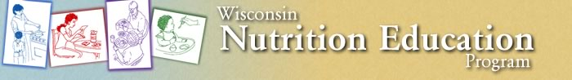
What is WNEP?

UW-Extension’s Wisconsin Nutrition Education Program (WNEP) helps limited resource families and individuals:
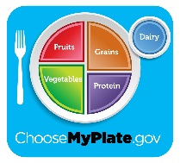
- Choose healthful diets and be physically active.
- Handle food safety to avoid food-borne illness.
- Become more food secure by making food spending plans, planning meals, and using thrifty food shopping practices.

WNEP is federally funded through SNAP-Ed (Supplemental Nutrition Assistance Program) dollars found within the Farm Bill. Families or individuals who are eligible for FoodShare (food stamps) are eligible for Nutrition Education with WNEP. Partners include: WIC, Head Start, and Food Pantries. Schools with a free and reduced lunch rate of 50% or more are eligible for Nutrition Education in the classroom (4K, Kindergarten, 2nd grade and 5th grade).
During fiscal year 2015, October 1, 2014 – September 30, 2015, Jackson and Trempealeau County WNEP provided 4,154 direct teaching contacts during 271 teaching events for a total of 187.50 hours of education. There were 3,949 indirect teaching contacts through parent handouts sent home with students. More detailed information about programming is available at the Jackson County UW-Extension office.
WNEP is staffed in Jackson County by the WNEP Coordinator who leads direct education, has administrative duties, and supervises the Nutrition Educator in Trempealeau County. The 2017 federal grant document is encouraging WNEP Coordinators to focus on policy, systems and environmental change involvement at the community level. Being part of coalition work (like Jackson in Action) and completing other multilevel work addresses the new focus. This addition to the mission of WNEP has led to a need for the Coordinator to have more time available to be in a community nutrition coordinator capacity.
Need for WNEP Support Staff

The Coordinator has budgeted $5,568,58 of federal WNEP grant funds to go towards an 8 hour support staff position for fiscal year 2017 (October 1, 2016 – September 30, 2017). Ideally this person would be the person already in the support staff position with UW-Extension for 32 hours a week. This person would help with WNEP agreement and budget paperwork, teaching event data entry, evaluation data entry, budget fund management, and copying parent and student materials and labeling them with the UW-Extension logo and contact information.

More details will be discussed at the meeting. Please bring questions and feedback about adding eight hours to the UW-Extension Support Staff position to support the Wisconsin Nutrition Education Program.

