
The 4-H Gateway Academy Offers:

- Fun and challenging hands-on, high
tech projects
- Valuable teamwork experience
- Real-world views of engineering and
technical careers
- Recreational opportunities
- Friendships with students who have
similar interests

The summer program is specifically designed by the Society of Manufacturing Engineers — Education Foundation and 4-H to help middle school students explore careers in science, technology, engineering and math.

For those students entering high school, now is the ideal time to start on the path toward a profession in technical careers.

The Bureau of Labor Statistics projects the demand for engineers to increase by 160,000 or 11 percent from 2006-2016.

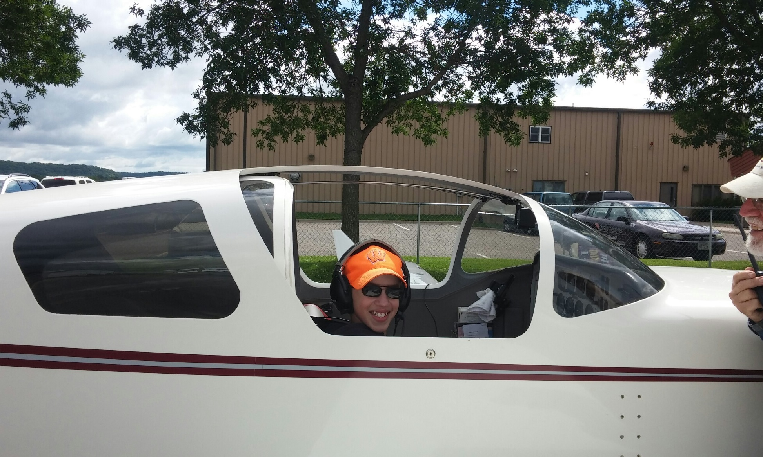

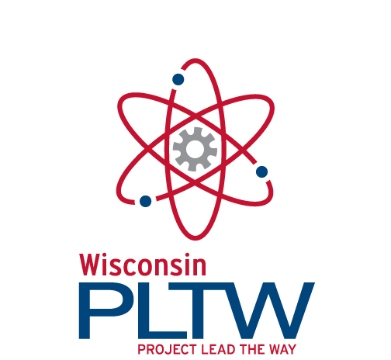

About UW-Extension-Pierce County 4-H

Children and youth build leadership skills, gain life skills, and explore careers through 4-H projects. Over 900 youth are members of 4-H in Pierce County. The 4-H Gateway Academy is a partnership which involves 4-H activities along with the development of hands-on, high-tech projects. Visit http://pierce.uwex.edu/4h to learn more about 4-H in Pierce County.

About the SME Education Foundation
The Society of Manufacturing Engineers
(SME) Education Foundation advances manufacturing education through youth programs and scholarships. Science, Technology, and Engineering Preview Summer (STEPS) Academy, now Gateway Academy, was created in an effort to fill the pipeline with skilled manufacturing workers. Visit www.sme.org/foundation for more info.

About Project Lead the Way (PLTW)

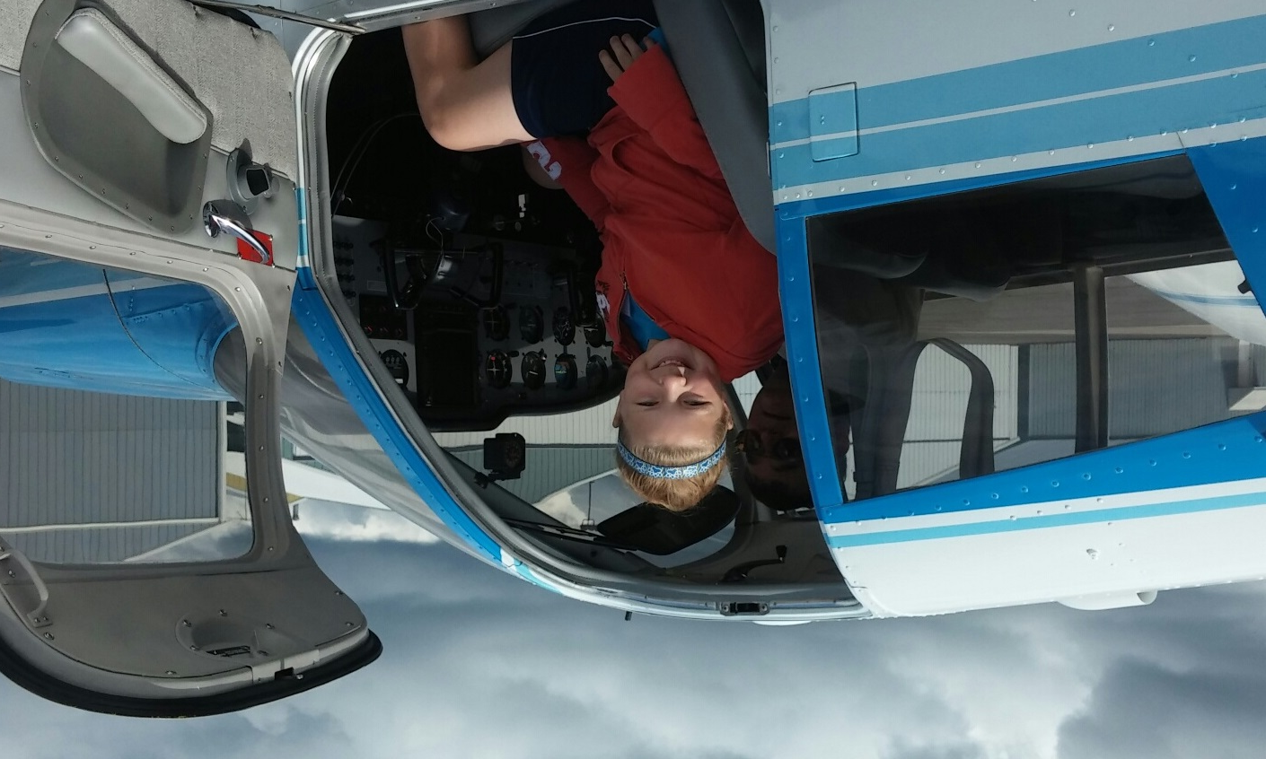
Project Lead the Way (PLTW) is a non-profit organization that provides pre-engineering curriculum for middle and high school students. Its Gateway to Technology program is the basis for the Gateway Academy. PLTW is in more than 2,000 schools in 40 states and the District of Columbia, educating more than 175,000 students. Learn more at www.pltw.org.

4-H Gateway Academy:
A Science, Engineering, Technology & Math Experience for Youth

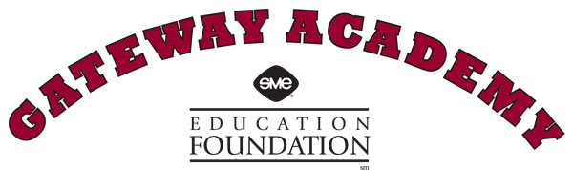

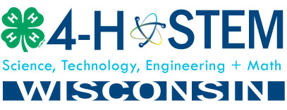

July 11-15, 2016
8:30 AM to 3:00 PM
River Falls High School Room D102

To Register:

Send in registration form, along with $100.00 fee for a one week camp. Enrollment is limited.
The 4-H Gateway Academy has instructors certified to teach this day camp. They will provide expert instruction in small group settings. During the week, campers will work together in a fun, exciting environment using leading-edge technologies to sample such disciplines as robotics, aeronautics, and computer design.

4-H GATEWAY ACADEMY APPLICANTS MUST BE:

- Boys or girls entering 6th, 7th, or 8th grade in the fall of 2016.

- Interested in science, technology, engineering or math careers.

- Comfortable working in a fast-paced environment.

- Curious about how things work.

- Willing to participate in the activities and the field trip.

- Eager to have fun, learn something new, and make new friends.

The 4-H Gateway Academy is a joint venture of
University of Wisconsin-Extension, the Society of Manufacturing Engineers (SME) Education Foundation, and River Falls School District

4-H GATEWAY REGISTRATION
Day Campers will be selected on a first-come, first-serve basis (limited to first 20) by completing the registration in this brochure and payment of a non-refundable $100.00 fee, which includes a t-shirt, field trip, lunches, and all classroom materials for the week. A portion of fee may be refunded if additional Academy funding is obtained.

For additional information please contact:
Frank Ginther, 4-H Youth Development Agent, francis.ginther@ces.uwex.edu or 715-273-6781.

Registration for Pierce County 4-H Gateway Academy

Student Name

First:

Last:

Grade: (2016-17 school year)

Address

Street:

City/Zip:

Parent or Guardian Name:

Home Phone:

Cell Phone:

E-mail:

Media Release (please check one)

___ I grant permission

___ I do not grant permission

I grant the University of Wisconsin Board of Regents, University of Wisconsin Extension and River Falls School District and agents unlimited permission to copyright and use, publish, and republish for purposes of advertising, public relations, trade or any other lawful use, information about my child’s participation in this program and reproductions (photographic or otherwise) of my child’s voice, likeness and any related creative works produced.

I have read all statements above and fully understand the contents. This release and contract shall be binding upon me and my legal representatives.

Parent or Guardian Printed Name

Parent or Guardian Signature and Date

Send completed registration form & check to: Pierce County UW-Extension
412 West Kinne Street
Ellsworth, WI 54011-0069
Make check payable to:
Pierce County 4-H Adult Advisors

T-Shirt Size – Circle Below –

Youth Large Adult Small Adult Med.

Adult Large Adult XL

