WINNEBAGO COUNTY

CHILD DEVELOPMENT PROJECT RECORD FOR 20

Things I plan to do and learn this year in this project are: (complete this box between Jan. 1 — May 1) | Check When Done

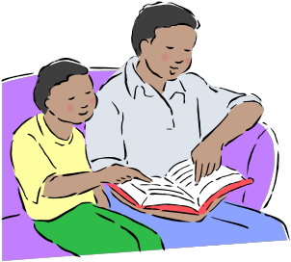CHECK SKILLS LEARNED OR IMPROVED

Understand developmental ages of children Recognize differences in children Accept differences
Recognize types of emotions
Recognize physical growth of children Recognize normal development
Learn to recognize special needs Observe and recognize child behaviors Motivate children to learn
Recognize role of fitness for children Create book of fun and nutritional
snacks for children
Make nutritional snacks with children Use positive discipline
Identify effects of television on children
Know child safety hazards in the home Know child safety hazards in the community Complete a babysitting training course Complete First Aid training

Complete CPR training
Select safe toys, games, songs, etc. Select age appropriate toys,
games, songs, etc.
Create games, toys, songs, etc. for learning Create book of outdoor and indoor games
for children
Teach self-care to children
Be a positive role model
Use a family rules guide
Encourage teamwork when with children Create an activity book for parents to use
with children
Use a home safety check list
Use a babysitting plan
Use written babysitting instructions check list with parents
Develop a personal child care resource library
Explore related careers/jobs
Other: please list

Ways You Received Help This Year Include: (check all that apply)
Exhibits in This Project:
Item Placing
(additional page may be added)

Attended project training offered by my club
Attended project training offered at the county level
Attended project training offered at District or State Level
Guidance from 4-H Leader/4-H Club
Guidance from Parent/Guardian/Other Adult
Reading and use of 4-H project guides
Reading and use of literature, books, audio visual resources
Own knowledge
Help from friends/other youth
Other (describe)

List at least 2 child development related careers that you can identify.
What did you learn or enjoy in the project this year?

Are you interested in a career related to child development?
Yes_ No_ Maybe_

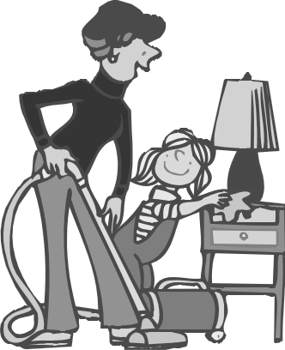

Project Worth Statement

What project related skill(s) would you like to learn or improve?

Has this project been worthwhile to you? Why or why not?

Revised 11/2006

