WINNEBAGO COUNTY

CONSUMER SAVVY PROJECT RECORD FOR 20

Things I plan to do and learn this year in this project are: (complete this box between Jan. 1 — May 1) | Check  When Done

Date | Describe Expenses: Supplies, etc. | Cost

Ways You Received Help This Year Include:
(check all that apply)
Exhibits in This Project:
Item Placing
(additional page may be added)

Attended project training offered by my club
Attended project training offered at the county level
Attended project training offered at District or State Level
Guidance from 4-H Leader/4-H Club
Guidance from Parent/Guardian/Other Adult
Reading and use of 4-H project guides
Reading and use of literature, books, audio visual resources
Own knowledge
Help from friends/other youth
Other (describe)

What do you enjoy most about the consumer savvy project?

What do you enjoy least about the consumer savvy project?

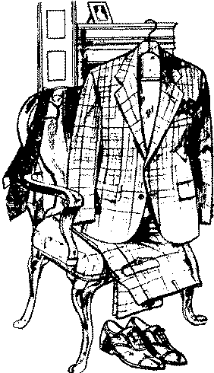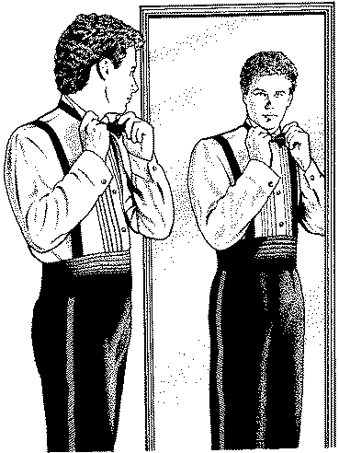List at least 2 consumer industry related careers that you can identify.

Are you interested in a career related to the consumer industry?
Yes_ No_ Maybe_

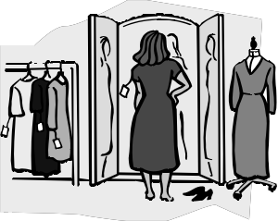

Project Worth Statement

What project related skill(s) would you like to learn or improve?

Has this project been worthwhile to you? Why or why not?

Revised 11/2006

