WINNEBAGO COUNTY

DAIRY PROJECT RECORD FOR 20

Things I plan to do and learn this year in this project are: (complete this box between Jan. 1 — May 1) | Check When Done

What did you learn or enjoy in the project this year?
What project related skill(s) would you like to learn or improve?

List at least 2 dairy industry related careers that you can identify.

Are you interested in a career related to the dairy industry? Yes_ No_ Maybe_

Ways You Received Help This Year Include:
(check all that apply)
Exhibits in This Project:
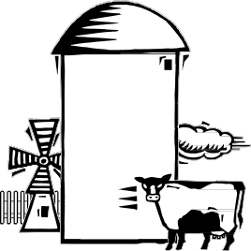Item Placing
(additional page may be added)

Attended project training offered by my club
Attended project training offered at the county level
Attended project training offered at District or State Level
Guidance from 4-H Leader/4-H Club
Guidance from Parent/Guardian/Other Adult
Reading and use of 4-H project guides
Reading and use of literature, books, audio visual resources
Own knowledge
Help from friends/other youth
Other (describe)

INDIVIDUAL ANIMAL RECORD
Choose (1) animal to report on, please include pictures on additional page.

Name Birth Date

Sire
Dam

Why did you select this animal for your Dairy Project?

What are the primary strengths of this animal?

What are the primary weaknesses of this animal?

Describe your involvement/work with your project animal(s) in the past year: (training, feeding, daily care, etc.)

Approximate Cost to Care for Animal from to
Value of feed purchased and/or grown | $
Veterinary/health expenses | $
Show supplies for year | $
Other: (please list)
 | $
 | $
 | $
 | $
 | $
Total Approximate Cost | $

Project Worth Statement

Has this project been worthwhile to you? Why or why not?

Revised 11/2006

