WINNEBAGO COUNTY

ELECTRICITY PROJECT RECORD FOR 20__

Things I plan to do and learn this year in this project are: (complete this box between Jan. 1 — May 1) | Check When Done

CHECK SKILLS LEARNED OR IMPROVED

Wire a simple circuit |  |  | Develop a basic electrical tool and supply kit
Compare open and closed switches |  |  | Read an electrical meter
Compare open and closed circuits |  |  | Understand wire and cable codes and symbols
Identify wire gauges and purposes |  |  | Read an appliance nameplate
Trace path of electrons |  |  | Understand local electrical codes
Identify conductors and insulators |  |  | Identify service entrance panel components
Understand magnetism |  |  | Identify incandescent, fluorescent & compact bulbs
Build an electromagnet |  |  | Explore cost efficiency of light bulbs
Define and correctly use electrical terms |  |  | Identify types of receptacles
Use a soldering iron |  |  | Use a voltage tester
Understand Ohm’s Law |  |  | Test grounded outlets
Use a Volt-Ohm meter |  |  | Calculate correct circuit wattage
Learn basic symbols |  |  | Identify and use electronic parts
Understand voltage in circuits |  |  | Demonstrate how diodes work
Learn difference between AC and DC |  |  | Use transistors
Replace a switch |  |  | Use resistors`
Design a three- or four-way switch |  |  | Understand capacitors
Read a circuit diagram |  |  | Other: (Please List)
Use digital and analog meters
Measure voltage
Understand series and parallel circuits
Test batteries
Design and use a momentary switch
Communicate in Morse Code

Ways You Received Help This Year Include:
(check all that apply)
Item | Placing

Exhibits in This Project:
(additional page may be added)

Attended project training offered by my club
Attended project training offered at the county level
Attended project training offered at District or State Level
Guidance from 4-H Leader/4-H Club
Guidance from Parent/Guardian/Other Adult
Reading and use of 4-H project guides
Reading and use of literature, books, audio visual resources
Own knowledge
Help from friends/other youth
Other (describe)

List at least 2 electrical industry related careers that you can identify.

Are you interested in a career related to the electrical industry?
Yes_ No_ Maybe_

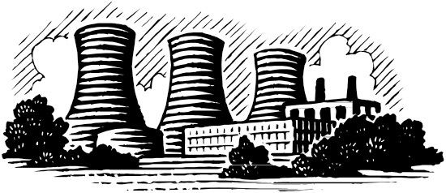

Project worth Statement
What did you learn or enjoy in the project this year?

What project related skill(s) would you like to learn or improve?

Has this project been worthwhile to you? Why or why not?

Revised 10/2019

