WINNEBAGO COUNTY

ENTOMOLOGY PROJECT RECORD FOR 20

Things I plan to do and learn this year in this project are: (complete this box between Jan. 1 — May 1) | Check When Done

Explain why you selected this project and how you feel about what you accomplished.

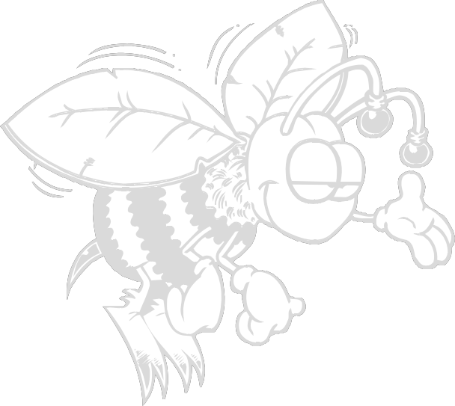CHECK SKILLS LEARNED OR IMPROVED

Identify parts of an insect’s body Identify seven insect orders Develop and use an insect key Recognize different insect mouth types
Learn collecting skills Prepare and mount insects Identify wing types and parts
Prepare an insect observation notebook Learn how insects communicate
Understand insect vision Keep insects as pets Learn insect habitats
Understand aquatic insects
Develop a butterfly garden
Study insect migration
Use an insect extractor
Use non-chemical insect control
Recognize pesticide chemicals on labels
Identify signs of insect damage
Identify signs of insect control
Compare insects with their relatives

Learn digestive system of insects Explore insects as food
Understand what insects eat Study insect movement
Make a spider web display
Identify how insects are used in marketing
Learn how insect use color to communicate
Study insect structures/homes Study insect habitat
Use integrated pest management Explore entomology careers Observe insect stages
Observe insect behavior using scientific method
Judge insect collections against a standard
Other: please list

Ways You Received Help This Year Include:
(check all that apply)
Exhibits in This Project:
Item Placing
(additional page may be added)

Attended project training offered by my club
Attended project training offered at the county level
Attended project training offered at District or State Level
Guidance from 4-H Leader/4-H Club
Guidance from Parent/Guardian/Other Adult
Reading and use of 4-H project guides
Reading and use of literature, books, audio visual resources
Own knowledge
Help from friends/other youth
Other (describe)

List at least 2 entomology related careers that you can identify.

Are you interested in a career related to the entomology industry?
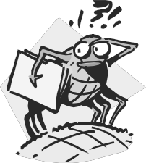Yes_ No_ Maybe_
What did you learn or enjoy in the project this year?

What project related skill(s) would you like to learn or improve?

Project Worth Statement

Has this project been worthwhile to you? Why or why not?

Revised 11/2006

