Things I plan to do and learn this year in this project are: (complete this box between Jan. 1 — May 1) | Check When Done

Entrepreneurship Skills
Managing Resources

WINNEBAGO COUNTY

ENTREPRENEURSHIP PROJECT RECORD FOR 20

CHECK SKILLS LEARNED OR IMPROVED Life Skills
Planning and organizing

Identifying potential business opportunities
Identifying an entrepreneurial venture Planning for business ownership Developing business agreements Thinking of cost
Identifying resources to make a business successful
Identifying available resources Presenting your business plan

Using information
Acquiring information
Understanding one’s abilities, strengths,
and limitations
Effectively sharing information Decision making
Contribution to group efforts
Wise use of resources
Communicating and making a presentation

Ways You Received Help This Year Include:
(check all that apply)
Exhibits in This Project:
Item Placing
(additional page may be added)

Attended project training offered by my club
Attended project training offered at the county level
Attended project training offered at District or State Level
Guidance from 4-H Leader/4-H Club
Guidance from Parent/Guardian/Other Adult
Reading and use of 4-H project guides
Reading and use of literature, books, audio visual resources
Own knowledge
Help from friends/other youth
Other (describe)

List at least 2 entrepreneurship related careers that you can identify.

Are you interested in a career related to entrepreneurship?
Yes_ No_ Maybe_

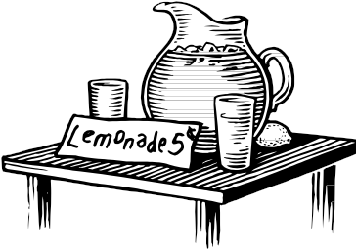

Project Worth Statement
What did you learn or enjoy in the project this year?

What project related skill(s) would you like to learn or improve?

Has this project been worthwhile to you? Why or why not?

Revised 11/2006

