WINNEBAGO COUNTY

EXPLORING PROJECT RECORD FOR 20

Things I plan to do and learn this year in this project are: (complete this box between Jan. 1 — May 1) | Check When Done

Describe 4-H projects explored: (What projects were explored? What was learned about the projects? Have you chosen a 4-H project because of exploration?)

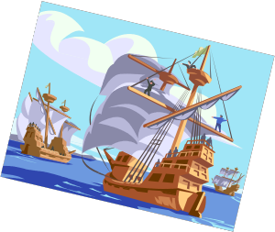Which part of the exploring project did you like best? Why?

Ways You Received Help This Year Include:
(check all that apply)
Exhibits in This Project:
Item Placing
(additional page may be added)

Attended project training offered by my club
Attended project training offered at the county level
Attended project training offered at District or State Level
Guidance from 4-H Leader/4-H Club
Guidance from Parent/Guardian/Other Adult
Reading and use of 4-H project guides
Reading and use of literature, books, audio visual resources
Own knowledge
Help from friends/other youth
Other (describe)

INDIVIDUAL ARTICLE RECORD
Choose (1) item to report on, please include picture on additional page.

Item made:
What did you learn by making this article?

Approximate hours to make: hours

Cost To Make Article

 |  | $
 |  | $
 |  | $
 |  | $
 |  | $
 |  | $
 | Total Cost | $

How will this article be used?

ARTICLES COMPLETED OR WORKED ON THIS YEAR:

Item/Title – Description Date Describe use: personal, gift, etc. Exhibited:

Project Worth Statement

Has this project been worthwhile to you? Why or why not?

Revised 11/2006

