WINNEBAGO COUNTY

HORSE/PONY PROJECT RECORD FOR 20

Things I plan to do and learn this year in this project are: (complete this box between Jan. 1 — May 1) | Check When Done

Information About Your Horse/Pony

Horse’s Name:
Age:
Sex:

Height:
pounds Weight: pounds Breed:

What are your horse’s strongest qualities? What qualities of your horse could be improved?

Vaccination Record

Eastern/Western Encephalomyelitis Date: Tetanus Toxoid Date: Equine Influenza Date:
Rhinopneumonitis Date:

Other:
Date:

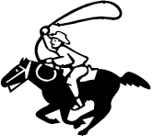 Date:
Farrier Record
Date | Work Done (trim, shoes, etc.) | Cost

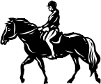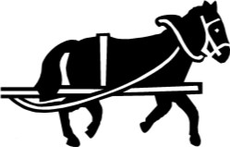

Describe what you do to care for and train your horse/pony.

Ways You Received Help This Year Include:
(check all that apply)
Exhibits in This Project:
Item Placing
(additional page may be added)

Attended project training offered by my club
Attended project training offered at the county level
Attended project training offered at District or State Level
Guidance from 4-H Leader/4-H Club
Guidance from Parent/Guardian/Other Adult
Reading and use of 4-H project guides
Reading and use of literature, books, audio visual resources
Own knowledge
Help from friends/other youth
Other (describe)

Project Expenses
Month | Feed & Bedding | Boarding  Fee | Lessons & Training | Health  Care | Equipment | Other | Totals

List at least 2 horse industry related careers that you can identify.
What project related skill(s) would you like to learn or improve?

Are you interested in a career related to the horse industry? Yes_ No_

Project Worth Statement

Has this project been worthwhile to you? Why or why not?

Revised 11/2006

