WINNEBAGO COUNTY

KNITTING OR CROCHETING PROJECT RECORD FOR 20

Things I plan to do and learn this year in this project are: (complete this box between Jan. 1 — May 1) | Check When Done

CHECK SKILLS LEARNED OR IMPROVED
Kind & size of yarns Abbreviations Read/follow directions Measure gauge Block/finish a garment
Tie/sew/conceal loose ends
Change colors
Insert markers
What did you learn or enjoy in the project this year?

What project related skill(s) would you like to

Make a woven seam
Make a button hole Proper laundering/care Cast on (chain) Increase and decrease Repair a mistake
Other: please list
learn or improve?

Ways You Received Help This Year Include:
(check all that apply)
Exhibits in This Project:
Item Placing
(additional page may be added)

Attended project training offered by my club
Attended project training offered at the county level
Attended project training offered at District or State Level
Guidance from 4-H Leader/4-H Club
Guidance from Parent/Guardian/Other Adult
Reading and use of 4-H project guides
Reading and use of literature, books, audio visual resources
Own knowledge
Help from friends/other youth
Other (describe)

Article 1 Article 2
Description:
Yarn Sample:
Pattern Source:
Date Started:
Date Finished:
Hours Worked:
Estimated cost if purchased | $
Number of skeins:
Cost per skein: | $
Total yarn cost: | $
Notions Used:
Total notions cost: | $
Total cost of article: | $

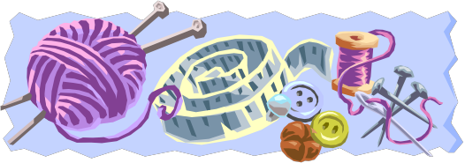

List at least 2 knitting industry related careers that you can identify.

Description:
Yarn Sample:
Pattern Source:
Date Started:
Date Finished:
Hours Worked:
Estimated cost if purchased | $
Number of skeins:
Cost per skein: | $
Total yarn cost: | $
Notions Used:
Total notions cost: | $
Total cost of article: | $

List basic supplies/equipment owned at the end of the year.

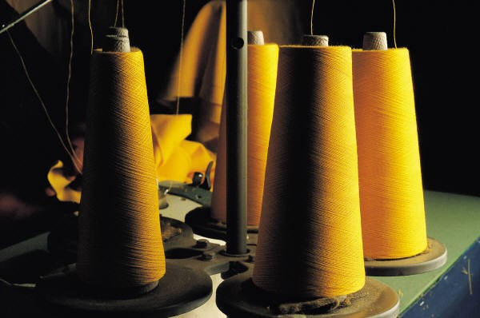Are you interested in a career related to the
Kkitting industry?
Yes_ No_ Maybe_

Project Worth Statement

Has this project been worthwhile to you? Why or why not?

Revised 11/2006

