Things I plan to do and learn this year in this project are: (complete this box between Jan. 1 — May 1) | Check When Done

Personal Finance Skills
Being a good consumer

WINNEBAGO COUNTY

PERSONAL FINANCE PROJECT RECORD FOR 20

CHECK SKILLS LEARNED OR IMPROVED

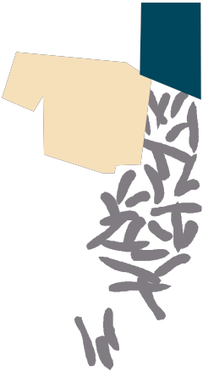Knowing how advertising influences purchasing decisions
Forming opinions about debt, credit, and loans
Managing money
Knowledge of personal finance Making consumer decisions
Recognizing income sources and expenses

Life Skills Making decisions Creatively
Planning and organizing
Acquiring and evaluating information Setting goals
Gathering information
Self management

Ways You Received Help This Year Include:
(check all that apply)
Exhibits in This Project:
Item Placing
(additional page may be added)

Attended project training offered by my club
Attended project training offered at the county level
Attended project training offered at District or State Level
Guidance from 4-H Leader/4-H Club
Guidance from Parent/Guardian/Other Adult
Reading and use of 4-H project guides
Reading and use of literature, books, audio visual resources
Own knowledge
Help from friends/other youth
Other (describe)

List at least 2 personal finance industry related careers that you can identify.

Are you interested in a career related to personal finance?
Yes_ No_ Maybe_

Project Worth Statement
What did you learn or enjoy in the project this year?

What project related skill(s) would you like to learn or improve?

Has this project been worthwhile to you? Why or why not?

Revised 11/2006

