WINNEBAGO COUNTY

ROBOTICS PROJECT RECORD FOR 20

Things I plan to do and learn this year in this project are: (complete this box between Jan. 1 — May 1) | Check When Done

CHECK SKILLS LEARNED OR IMPROVED

Learn about famous robots Define robotic terms Robotics skillathon Exploring gears
Creating an electrical circuit Navigational tracking Sensory exploration
Mechanical assembly and use of tools Programming and coding
Research robotic careers Communicating with others Leading self and others Planning and organizing Communicate creatively Critical thinking
Problem solving Following directions Decision making Other (please list):

Ways You Received Help This Year Include:
(check all that apply)
Exhibits in This Project:
Item Placing
(additional page may be added)

Attended project training offered by my club
Attended project training offered at the county level
Attended project training offered at District or State Level
Guidance from 4-H Leader/4-H Club
Guidance from Parent/Guardian/Other Adult
Reading and use of 4-H project guides
Reading and use of literature, books, audio visual resources
Own knowledge
Help from friends/other youth
Other (describe)

List at least 2 robotics industry related careers that you can identify.

Are you interested in a career related to robotics?
Yes_ No_ Maybe_

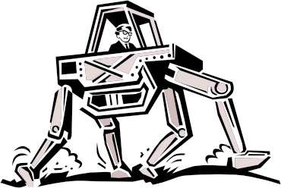

Project Worth Statement
What did you learn or enjoy in the project this year?

What project related skill(s) would you like to learn or improve?

Has this project been worthwhile to you? Why or why not?

Revised 11/2006

