WINNEBAGO COUNTY

SWINE PROJECT RECORD FOR 20

Things I plan to do and learn this year in this project are: (complete this box between Jan. 1 and May 1) | Check When Done

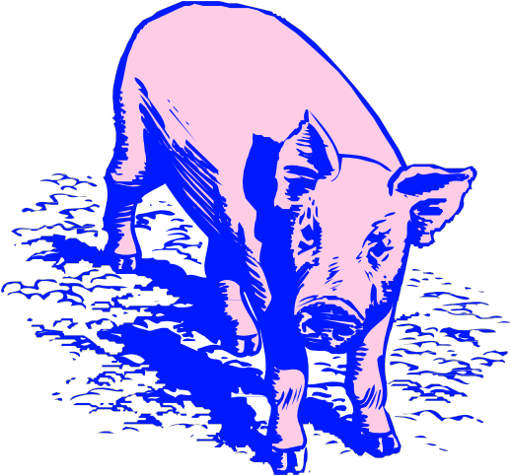What did you learn or enjoy in the project this year?

What project related skill(s) would you like to learn or improve?

Ways You Received Help This Year Include:
(check all that apply)
Exhibits in This Project:
Item Placing
(additional page may be added)

Attended project training offered in the county
Attended project training offered at District or State Level
Guidance from 4-H Leader/4-H Club
Guidance from Parent/Guardian/Other Adult
Reading and use of 4-H project guides
Reading and use of literature, books, audio visual resources
Guest presenters
Own knowledge
Help from friends/other youth
Other (describe)

INDIVIDUAL ANIMAL RECORD
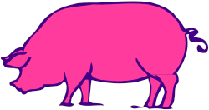Choose (1) animal to report on, please include pictures on additional page.

Market Hog Estimated Feeding Plan
(Do for at least one market hog.)

Animal’s Name/Identification:

1. Date of purchase: and/or Date of birth:

2. Weight at Start of Project: (Spring weigh-in):
Date:

3. Projected finish weight:
Projected net gain:

4. Date of entry day at county fair:
weight.)
(This is the date of projected final market

5. Number of days from project start date to entry day:

6. Average daily gain will need to be pounds per day to reach planned finish weight.

7. Actual weight on entry day of county fair: Actual net gain:

8. Actual rate of gain (net gain ÷ number of days from start to finish):

9. How does this rate of gain compare to current swine industry performance standards?

Low
Near
High
Explain:

Management Practices

Vaccination/deworming dates:

List at least 2 livestock industry related careers that you can identify.

Product used:

Describe your feeding program:

Are you interested in a career related to the livestock industry?
Yes_ No_ Maybe_

Project Worth Statement

Has this project been worthwhile to you? Why or why not?

Revised 03/2006

