WINNEBAGO COUNTY

YOUTH LEADERSHIP PROJECT RECORD FOR 20

Things I plan to do and learn this year in this project are: (complete this box between Jan. 1 — May 1) | Check When Done

Youth Leader Role (check all that apply)

Project Helper Project Leader Activity
Club Officer
Committee Chairperson
General Helper
County Level
Dist. or State Level Other (describe)

Ways You Received Help This Year Include:
(check all that apply)
Exhibits in This Project:
Item Placing
(additional page may be added)

Attended project training offered by my club
Attended project training offered at the county level
Attended project training offered at District or State Level
Guidance from 4-H Leader/4-H Club
Guidance from Parent/Guardian/Other Adult
Reading and use of 4-H project guides
Reading and use of literature, books, audio visual resources
Own knowledge
Help from friends/other youth
Other (describe)

Describe the major things done as Youth Leader. Did you teach members this year? Did you help leaders? Did you plan club or county activities? List what you did, number of people reached and the results of your effort.

What did you learn or enjoy in the project this year?

What project related skill(s) would you like to learn or improve?

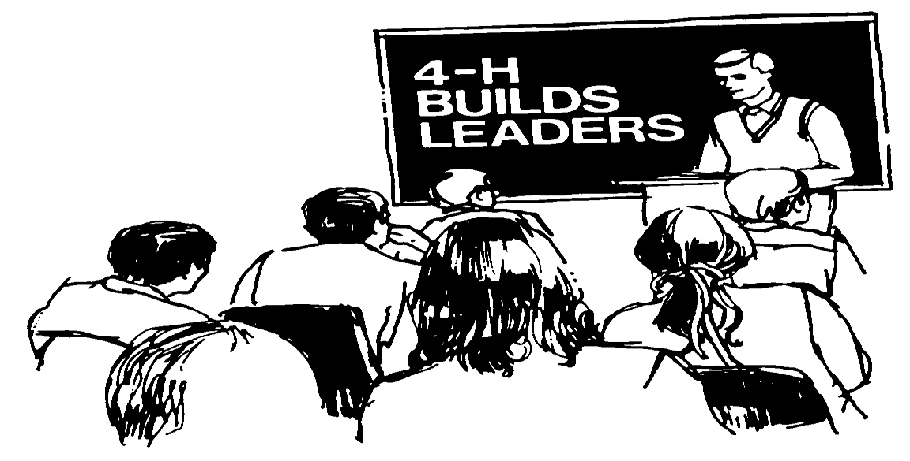List at least 2 leadership related careers that you can identify.

Are you interested in a career related to leadership?
Yes_ No_ Maybe_

Project Worth Statement

Has this project been worthwhile to you? Why or why not?

Revised 11/2006

